University of Missouri
Request for Qualification Response

3/23/2012

Table of Contents

Airgas USA LLC Company Summary
- Social and Environmental Responsibility
- Airgas Known Locally
- Airgas Service Commitment; Delivery, Support and Emergency contact
- Airgas Service Commitment; Aero Team, Training and Orphaned cylinders

- Airgas Service Commitment; Cylinder tracking with AIM™
- Gas Capabilities; Medical
- Gas Capabilities; Specialty and Lab Gases
- Gas Capabilities; Bulk/Micro Bulk, C02, Helium
- References

Airgas. You'll find it with us. 1

Corporate Profile

Airgas USA LLC. (NYSE: ARG), through its subsidiaries, is the largest U.S. distributor of industrial, medical, and specialty gases and hardgoods, such as welding equipment and supplies. Airgas is also one of the largest U.S. distributors of safety products, the largest U.S. producer of nitrous oxide and dry ice, the largest liquid carbon dioxide producer in the Southeast, the fifth largest producer of atmospheric merchant gases in North America, and a leading distributor of process chemicals, refrigerants and ammonia products.

Airgas Chairman and Chief Executive Officer Peter McCausland founded the company in 1982. Through nearly 400 acquisitions and internal growth, Airgas has built the largest national distribution network in the U.S. packaged gas industry. More than 14,000 employees work in approximately 1,100 locations including branches, retail stores, packaged gas fill plants, cylinder testing facilities, production facilities, specialty gas laboratories, and distribution centers. Airgas markets its products through multiple sales channels including branch-based sales representatives, retail stores, strategic customer account programs, telesales, catalogs, eBusiness and independent distributors. Airgas’ national scale and strong local presence offer a competitive edge to its diversified customer base.

SOCIAL AND ENVIRONMENTAL RESPONSIBILITY 2
Airgas maintains a deep commitment to safety, the environment, our communities and our military personnel and the families who support them.
Safety Responsibility
Airgas has more than 5,000 vehicles in its fleet – and the lowest accident rate of any large fleet in the industry. Based on our 2010 driving record, we earned the top fleet safety awards from the Compressed Gas Association (CGA) for the second straight year. The CGA recognized us for the best safety record among bulk gas fleets with more than 20 million miles driven and the best safety record among cylinder gas fleets with more than 3 million miles driven. We are now a three-time winner of the CGA bulk transportation award and four-time winner of the cylinder transportation award.

Calendar Year | Fleet Vehicle Accident Frequency Rate | Preventable Vehicle Accident Frequency Rate
2006 | 3.2 | 1.9
2007 | 3.1 | 1.7
2008 | 3.0 | 1.6
2009 | 2.8 | 1.5
2010 | 3.2 | 1.4
(accidents per million miles driven)
In our operations, safety continues to be a priority, and we maintained low levels of recordable injuries and lost workdays in 2010.

Calendar Year
Total Recordable Injury
Incidence Rate
Lost Workday Incident Rate

2006 | 3.0 | 0.6
2007 | 3.0 | 0.6
2008 | 2.7 | 0.4
2009 | 2.5 | 0.5
2010 | 2.5 | 0.5
(per 200,000 hours worked)
Environmental Responsibility
Airgas is constantly improving our operations to be more environmentally responsible and adding new products and services that help keep our planet and skies as clean and healthy as possible. In the past year, we made a positive contribution in a number of ways:
Operations and fleet
Increased energy efficiency at our 15 air separation units by 3 percent
Reduced water usage by 14 million gallons through our continued transition from hydrostatic cylinder testing to ultrasonic cylinder testing
Added our first hybrid truck – which will reduce diesel fuel usage and carbon dioxide emissions by 12 percent for that vehicle – to our delivery fleet
Social Responsibility
In fiscal 2011, Airgas celebrated our third year of financial commitment to Operation Homefront, a non-profit organization that provides assistance to U.S. troops, to the families they leave behind and to wounded warriors when they return home. This latest year included several milestones:
Reached our goal of hiring 100 veterans of Iraq and Afghanistan – and continue to actively recruit veterans for positions within Airgas
Extended our financial commitment to Operation Homefront for another year
Continued to expand employee volunteerism for Operation Homefront, including adopting military families and organizing and participating in fundraising events

Airgas Known Locally 3
Airgas USA LLC in Missouri has locations next to all four system schools, as well as FDA medical, and ISO9001 specialty gas fill plants, and sales team ready to meet all the University’s immediate needs. All fill plants in Missouri store an ample supply of critical gasses and storage trailers for emergency backup supply. Airgas has the ability in an emergency situation, to dispatch critical equipment and gasses throughout Missouri within hours of an emergency.
20+ Large branch locations

AERO team (Airgas emergency response Organization) more on page 5

- 30 + AERO response employees at locations across the state Cylinder testing / rehab facility
- Mt Grove

6 FDA Medical fill plants

- Sedalia, (2)St Louis, Kansas City, Springfield, Mt Grove ISO9001:2000 Specialty Gas Lab with AccuGrav
- St Louis Sales Team
- University Specialist, Derek Ranabargar, dedicated to the University of Missouri System

- 60+ Account Managers

- 8 Specialist ( Safety, Spec gas, Welding, University)

Large branch locations across the state.
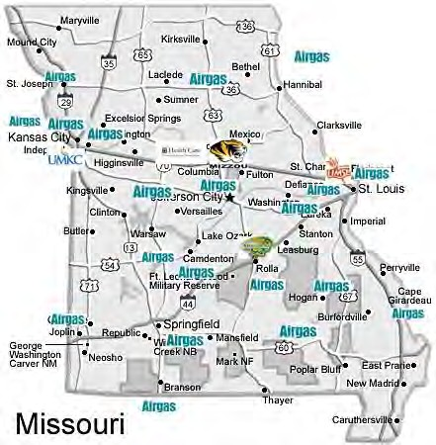

Airgas is committed to the highest level of service to the University System. Our vision is to bring more value to the University’s operations, and advance the customers purchases through a variety of options in handling, delivery, storage, training, and inventory management. Airgas’ Show Me Shops punch-out would be enhanced with a level II upgrade.

Next day delivery
Airgas will offer next day delivery to all customers who have their order in by 3pm the day prior. Delivery will be made to customer’s location of choice in a safe manner. Airgas will deliver directly to labs.

Delivery Service
We know how important it is to get the critical gases delivered on time, and safely. Airgas will provide the Columbia campus and Hospitals with a dedicated delivery driver and truck. All other locations will be delivered out of the corresponding branch in that town with next day delivery. Airgas keeps its fleet well maintained, but as we all know breakdowns happen. In the event of a breakdown, Airgas keeps a back up route truck at every branch ready to go so that there is no delay in getting the customers what they need.

Support Staff
Airgas knows the importance of support. Airgas not only has a dedicated specialist, but a back office support staff to meet any needs of the University. Our support staff is housed in the Holts Summit, Missouri facility ready to work with any tasks such as billing, credit, collections, invoicing, Sciquest orders, and to assist customers or internal University staff.

Emergency orders/shipments
Airgas is offering 24/7 emergency delivery, and contact numbers. There will be multiple contacts per location, as well as one standard contact for all locations. This number is listed below.
Derek Ranabargar Cell – 573-544-5690
Derek.ranabargar@airgas.com

SciQuest Punch-out
Airgas' corporate eBusiness team is dedicated to implementing eMarket solutions for those customers who require electronic procurement. The corporate eBusiness team works with our national and local commercial sales force to ensure all customer needs are met throughout the duration of the project. With corporate support, Airgas has the ability to offer complete procure-to-pay solutions, if requested. The eBusiness team is currently developing the ability to offer Level II punchouts for our customers. Although embryonic, Level II punchouts can provide the ability to enhance the end users experience through a new search and data available for analysis.

Aero Response Team
Product safety and emergency response is a part of our total commitment to our customer. Emergencies involving compressed gases require highly specialized skills, techniques, and equipment. The actions taken in the first five minutes are critical. Nobody knows Airgas products better than we do. That’s why we formed the Airgas Emergency Response Organization, comprising:
250 hazmat technicians across the country
More than 25 full teams and eight satellite teams nationwide, for fast response. The best hazmat technician training in the industry
Specialized containment vessels and vehicles to isolate and transport leaking cylinders safely Chemical expertise needed to analyze and identify unknown gases and to determine proper handling and disposal methods

Training/Safety
Airgas has long been a partner with EH&S across all campus locations. We offer many training classes to EH&S, students, staff, and professors as well as the chance to train with our AERO team for cylinder emergency response. When the University of Missouri procures it gasses through Airgas we provide training at no cost. Below are some of the classes we offer.
Safe handling of compressed gases Cryogenic safety
Welding and gas safety Lab safety audit
NFPA bulk safety audits Hospital gas safety training Hospital compliance audit Regulator safety training

Orphaned tanks and lecture bottle disposal
Airgas works with many cylinder disposal companies to protect the environment by disposing of cylinder lecture bottles correctly and safely. Airgas helps the customer package and define what is in the tank so it is ready for disposal. Airgas has a solution to replace the lecture bottle for good; we use our Safe-T Cyl to replace hard to get rid of lecture bottles. Safety-T-Cyl is a re-fillable tank so it eliminates the need for costly disposal and environmental waste.

E&I / Novation
Airgas has procurement agreements with many of the large cooperative groups. E&I and Novation are among many of the solutions Airgas has relationships with.

Cylinder Tracking
In an effort to provide continuous improvement, Airgas would like to propose upgrading the University to our Asset Management System that we call AIM™ (Airgas Inventory Management) System. AIM™ is an INTERNET BASED inventory management system that would allow the University complete control of cylinder balances, and acts as a data collection repository and analysis tool to “help translate information into
business value.” AIM™ is both an internal and external system and is highly configurable to meet the
University’s exact needs. Orders placed in SciQuest would be processed in AIM™ as AIM™ interfaces with Airgas’s SAP back office.

Using its knowledge in cylinder gas supply, Airgas will work with the University to establish improvement goals including inventory reduction. Categories for cost improvements will be documented and tracked real time. Airgas personnel will provide as-needed technical support and training to all laboratories to ensure that proper equipment is being utilized and proper safety procedures are being followed. With the AIM™ system, all delivered cylinders will be tracked via barcode. Cylinders will be scanned with a Handheld Unit (HHU) upon delivery and data will be available real time. Scheduled audits will be completed to ensure cylinder inventories are correct and cylinder locations are updated in the event a cylinder is moved to another location. AIM™ has the capability to provide discrepancy reports so that all cylinders can be reconciled to their proper location. Additional functionality and reporting is as follows:

Reports (Cutomer) Reports (Airgas)

Order forecasting based on prior usage patterns with email notification. Usage calculations to ensure proper min/max levels are properly maintained.
Cylinder utilization report identifying non-returned cylinders (e.g. cylinders on-site more than 12 months).
Real time - SARA reporting for annual pounds and pounds on site by material and location.
Approval layers to ensure restricted products cannot be ordered without Risk Management & Safety
approval (if ordered within AIM™). Paperless delivery ticket and invoicing.
PO/Grant fund tracking with PO expiration date email notification.
Cylinder Audits taken with the AIM™ Hand Held Unit and reconciled within AIM™. Online access to MSDS.
Online access to Certificates of Analysis (COA).
Email notification of shelf life expiration for EPA protocols and other identified gases. Historical usage reports filtered by location, material type, etc.
Enterprise visibility to your inventory “real time” to include end users, if granted

Medical Gas
Airgas offer the industry’s widest offering of quality medical gas products and related equipment. It’s now easier than ever to meet all your medical gas needs because one source has it all. Airgas operates more than 250 FDA accredited fill plants, and owns the nations larges medical cylinder fleet.

Medical gases we offer
Medical grade
- Carbon Dioxide
- Helium
- Air
- Nitrogen
- Nitrous Oxide
- Oxygen Medical mixtures
- Laboratory and Technical Gases Two-Component Mixtures
Clinical Blood Gas Mixtures Tonometry Standards Transcutaneous Monitor Standards
Pulmonary and Lung Diffusion Mixtures Medical Laser Gas
Biological Incubation Atmospheres Gas Chromatography Mixtures Sterilant Gas
Cylinder and Bulk Delivery Dry Ice

Airgas Walk-02-Bout
The Airgas Walk-02-Bout family of products is an innovative solution to issues that first responders and healthcare practitioners face in quickly and safely providing respiratory care to patients. Walk-02-Bout lightweight aluminum cylinders with built in regulator and DISS outlet and a wide permanent handles make it easy to lift and carry anywhere. The Walk-02-Bout is offered with many tank (E, D, M6, M9 ….) and valve options.

Airgas offers the Walk-02 Bout in the following options.

Medical Oxygen MRI Compatible Pediatric HE/OX EMS
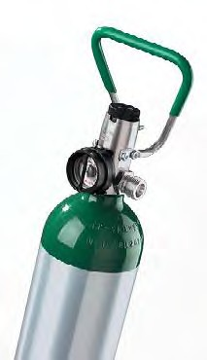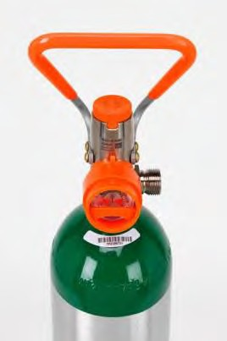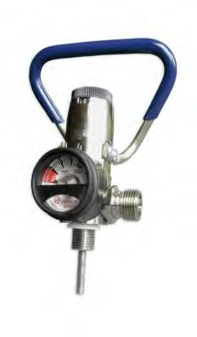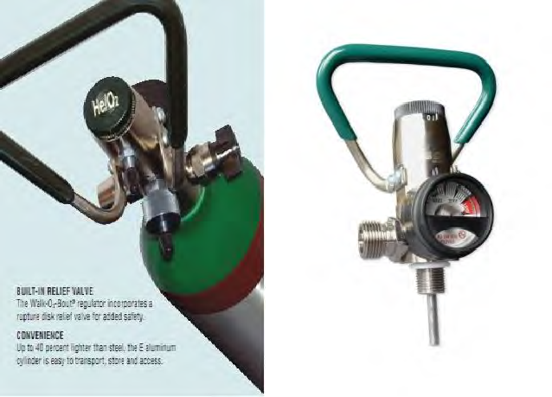

Specialty and Lab Gases
Airgas maintains the latest analytical equipment and techniques to assure precise, analytical data. Nearly two thirds of Airgas specialty gas labs are ISO 9001 registered and three are also ISO/IEC 17025 accredited.
Airgas engineers developed AcuGrav, a totally computerized and automated high-tolerance specialty gas filling system. The result is precise, quality gas mixtures every time. You get accuracy, consistency and reliability.

Our Specialty gases and related products include:
Ultra High Purity and Ultra Pure Carrier grade gases BIP Technology gases
- Argon, Helium and Nitrogen tanks with an exclusive built-in purifier that converts zero- grade as into premium grade gas before it exits the cylinder
Pure Hydrocarbons Calibration Standards EPA Protocol Standards BAR gases
Vehicle Emissions Standards VOC Mixes
Electronic Grade gases Laser Gases
Process Chemical Dry Ice

Airgas sets the standard for specialty gases, literally. NIST has chosen Airgas to provide the Standard
Reference Materials (SRM’s) gas mixtures used worldwide. NIST SRMs are the yard stick by which all other gas mixtures are measured.

Safe-T Cyl
Lecture bottle disposal is a major concern at a University. Airgas engineered Safe-T-Cyl to provide small volume, specialty gas and process chemical customers with an alternative – a returnable, refillable small cylinder package. With Safe-T-Cyl there is no disposal cost, and it is good for the environment.

Refrigerant
Airgas is the largest refrigerants distributor in the U.S. and warehouses refrigerants in multiple states across the country. Airgas not only sells refrigerants but we also buy used refrigerant with our refrigerant reclaim services. Airgas operates an on-site reclamation, recovery, dehydration, flushing, system conversion and disposal service. Airgas can also process refrigerants on-site and return refrigerant to ARI-700 purity standards.

Specialty Gas Equipment and Engineering
Airgas has their own brand of specialty gas equipment to meet any need of the customer. Airgas offers custom built manifold systems, gas cabinets, monitoring equipment, regulators, changeover panels and much more. Below are some examples of our equipment and Engineered solutions.

Bulk / Micro Bulk
Airgas provides a wide variety of readily available products. Along with standard atmospheric gases, we offer hard-to-find specialized products, such as Nitrous Oxide and FDA-approved Carbon Dioxide. We also provide high-quality storage systems designed to meet or exceed industry standards. All products, storage and delivery systems can be custom-tailored to meet customer requirements. Our bulk gas offering includes the following industrial gases: Argon, Nitrogen, Oxygen, Carbon dioxide, Hydrogen and Helium.

Food Grade C02
Airgas National Carbonation is a national supplier of both BevCarb and gas cylinder carbonation systems. Backed by the power of Airgas, Airgas National Carbonation is close to you with more than 1,200 locations nationwide, including St Louis Missouri. We offer single-source efficiency for all your carbonation procurement, installation and service needs. Dedicated to the highest safety and service standards, we partner with you to develop a custom program to fit your needs. Our deliveries comply with your schedules, ensuring your carbonation supply won't run out—ever. With Airgas National Carbonation, you can worry less about carbonation and concentrate more on building your business.

Helium Supply
As you know the world is in a helium shortage. Helium supply shortages that began in the spring and were thought to be temporary have intensified. Production outages at major helium sources worldwide are causing persistent supply challenges. The University remains top priority to Airgas. Any allotment Airgas maintains is first delivered to the University. As always we will deliver medical/MRI helium first and Research second. Balloon and welding helium are last filled.

– With current tightness, any production disruption causes significant product shortage
and dislocation
  - U.S. is an exporter of helium
  - BLM output issues – Began May 2011 and are still ongoing
– BLM accounts for 35% of overall global output
  - Exxon Outage – Began August 1 and ended September 15
– Created a crisis; resumption of production returned us to an already tight market
2

University

Case Western Reserve University
Melinda Boykin, Director - Strategic Sourcing 216-368-3245
melinda.boykin@case.edu

Cornell University
Susan Morse, Purchasing Agent/Strategic Sourcing Manager Lab, Science, Animal & Agriculture
607-255-9192
sm32@cornell.edu

Virginia Tech University
Tom Kaloupek, Director of Materials Management 540-231-6221
kals@vt.edu

University of California - Davis
Mike Morgan, Strategic Sourcing Material Manager 530-754-1349
mamorgan@ucdavis.edu

Medical

Boone Hospital Center, Columbia Mo Brian Walker, Manager Respioarty Care 573-815-3653
bwalker@bjc.org

A.T. Still University
Corey Louder, Procurement 660-626-2203
clouder@atsu.edu

Barnes Jewish Hospital / Washington University
Jeannine Cahill MT (ASCP)
Senior Contract Management Liaison 314-935-4395

Thank you for the opportunity to continue our relationship with the University! Please contact me if you have any questions about our proposal.

.

Hydrogen Car team Sponsor ESPN Game Day Sponsor Tiger Football Sponsor

Life Science Week 2011

Derek Ranabargar University Specialist Airgas USA LLC
573-544-5690
derek.ranabargar@airgas.com

