Executive Summary of Program Assessment

The summary, including this page, should be no more than three pages.

Campus: University of Missouri-St. Louis

College/School: College of Arts and Sciences

Academic Unit: Department of Biology

Date Submitted: 09/16/19 (dd/mm/yy)

Person Responsible for Success of Program: Dr. Wendy Olivas

Submitted by: Amber Reinhart

Degree Programs
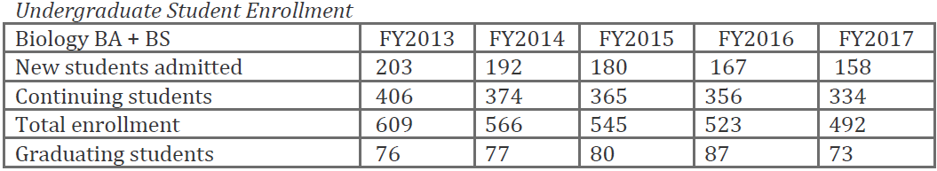

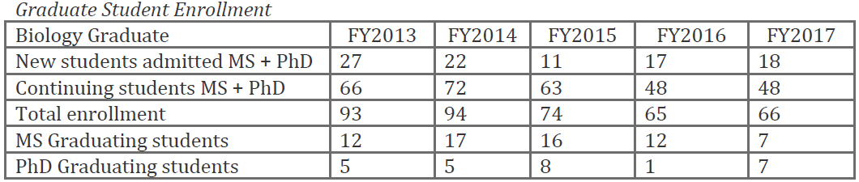

Changes since Last Review
During the summer of 2016, Wendy Olivas became the new chair of the department. During this time the department was also in the middle of interviews for an Assistant Professor position in spring 2016 when the University cancelled the search due to budget cuts. Financial constraints of the University and College have also caused reductions in the general (7%) and graduate (20%) budgets of the Department, and all carry-forwards in accounts were frozen. These cuts have had negative impacts on the department’s programs, students, and overall morale.

Strategies or Plans for Improving Program
The number one priority of the Biology Department is to increase the number of research faculty and invest resources to promote their success. With the ever-increasing loss of research support from the University, it will be imperative to increase external grant support for our activities and infrastructure. With increased faculty numbers, the department will also be able to better support our teaching and community engagement missions and grow the student body of the department.

