Introduction to Academic Advising at the University of Missouri
Module 4: Legal and Ethical Issues
- Introduction
As an advisor you play many roles. You are a safe place for students to explore their personal and academic goals but you are also an enforcer of policies and procedures. You have responsibility to your students, your institution, and your peers. Unfortunately, sometimes these different roles come into conflict and you may have to make some judgement calls.
This module provides an introduction to legal and ethical issues related to academic advising. These two topics are often discussed together, and while they both relate to behavior, each uses a different lens to decide what action is needed. As we’ll see later, legal and ethical behaviors do not ALWAYS coincide.
Legal guidelines specify what you should NOT do. In following them, you are striving to AVOID doing something that is prohibited.
Ethical behavior, on the other hand, is about making the best choice of action out of all possible alternatives whether those alternatives be legal or not. Many times all possible alternatives are legal, but that doesn’t mean that they are all ethical. That’s where decision-making comes in. So let’s start by looking at some of the ethical principles related to academic advising.
- Ethical Principles Related to Academic Advising

- Ethical Ideals
[Intro] Please watch this short video about the four ideals that provide the foundation for ethical practice in academic advising.
[Video] We can probably agree that in order to act ethically, we must suspend what is personally at stake in a given situation in order to consider the consequences of our actions on others. In simplified terms, acting ethically means doing the “right” thing for the right reason. But how do we know what IS the right thing to do?
Lowenstein and Grites (1993) discuss four ideals of ethical behavior drawn from a long history of ethical thinkers. The four ideals are Utility, Justice, Respect for Persons, and Fidelity. They use these four ideals to inform ethical principles for advisors which we will talk about shortly.
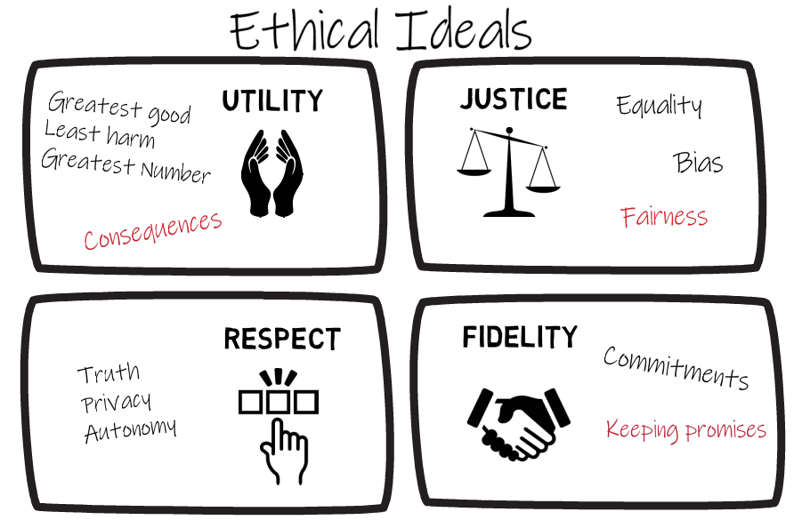

The first ethical ideal is Utility. Utility is the balance between harm and benefit. In other words, doing the greatest good or least amount of harm for the greatest number of people in both the long term and short term. According to this ideal, actions are judged by their consequences.
The second ideal is Justice which means treating all people equally. Bias seriously impedes the ideal of justice. We will talk more about bias in Module 5. According to this ideal, fairness is a desirable outcome unto itself regardless of the consequence.
The third ideal is Respect for Persons which means treating individuals as rational and autonomous and NOT as means to our own ends. This is demonstrated in rules such as telling students the truth, respecting privacy, and supporting an individual’s autonomy.
The fourth ideal is Fidelity which means living up to commitments we have made. Unlike utility, fidelity is not judged on consequences but on the extent to which we are keeping our promises.
These ideals can be used to guide our actions. When facing a decision, we can compare all of the possible options based on whether they meet these ideals. We ask ourselves “Which of the choices will help the most people, treats all people equally, shows respect for others, and keeps the promises that we’ve made?”
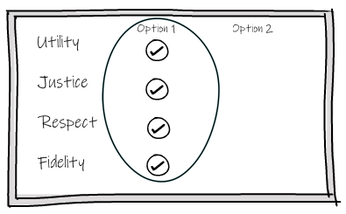
Unfortunately, many situations are not so cut and dry with ONE option meeting all ideals and another meeting none. Ethical dilemmas arise when these ideals are in conflict. In these situations, choosing one option means deciding to disregard one or more of these ethical ideals.
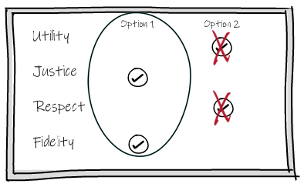
Next, we will look at NACADA core values and how these relate to ethical ideals.

- NACADA Core Values
You will remember from Module 1 that NACADA has identified Core Values to guide academic advising practice. These were recently updated to shift away from focusing only on behaviors to focusing on the beliefs that influence how advisors act. In looking at the Core Values, you can see how they arise from the four ethical ideals we just discussed. Although you might find some overlap, respect and caring come from the ideal of respect for persons, inclusivity is grounded in the ideal of justice, empowerment relates to utility, AND integrity, commitment and professionalism are based in the ideal of fidelity. Follow the link for a description of each of the NACADA Core Values.

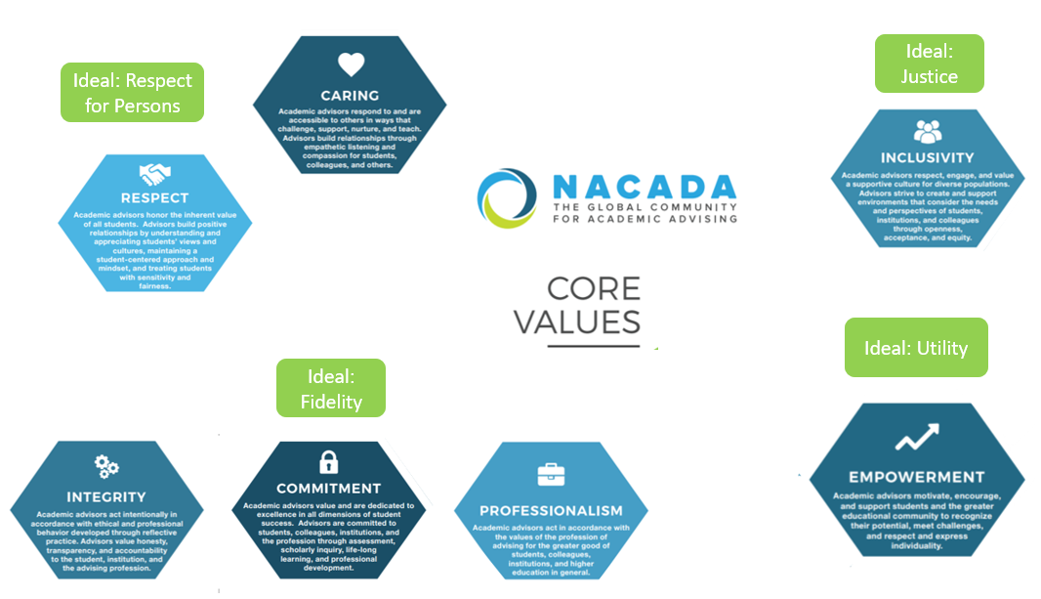

- CAS Standards
So now that we understand the ideals and values that provide a foundation for ethical academic advising practice, let’s look at what the Council for the Advancement of Standards in Higher Education (CAS) tells us. You can review program standards from the provided link. CAS Standards Part 5 also provide specific guidance to academic advisors. It tells us that advisors must:
- Employ ethical decision making in the performance of their duties – we will talk more about strategies that can help you make ethical decisions a little later.
- Advisors must also uphold policies, procedures, and priorities of their departments and institutions – this is a matter of fidelity. When you accept a position with the university, you are making a promise to uphold its priorities.
- You should also inform students of any ethical obligations or limitations that you might have related to your interactions. This is an area you should clarify with your supervisor.
- Advisors must recognize and avoid conflicts of interest and, when unavoidable, recuse themselves from the situation
- It is important that advisors perform their duties within the scope of their position, training, expertise, and competence – be clear about what activities are the job of an advisor and which fall outside of the scope of your position. There may be situations that arise, especially as you are newer to your position, that fall outside your competence level or your expertise. It is far better and more ethical for you to recognize this and ask for help or make referrals when issues presented exceed the scope of the position.
- And lastly, advisors recognize their responsibility to ensure THE privileged, private, and confidential nature of interactions with students IS not sacrificed – this seems obvious, but especially at times when we are trying to get things done for a student we need to consider how much information the other party really needs in order to make a decision or complete a task. In situations where knowing more might be helpful, consider talking to the student about whether they might share the information themselves.
Next we’ll look at some strategies for dealing with ethical dilemmas in advising.
- 8 Ethical Principles for Advising
An advisor is bound by the commitment they have made to their institution to support the institution’s policies (#6) and maintain credibility of the advising program (#7). Advisors must seek the best possible education for their advisees (#1) while treating students equitably (#2). In order to enhance the advisee’s ability to make decisions (#3), advisors must tell the truth about college policies and procedures (#5). In order to seek the best education, advisors may need to advocate with other offices on behalf of the student (#4) but should always do so with courtesy and respect (#8) while balancing sharing the truth and respecting the confidentiality of interactions with the advisee (#5)
- Seek the best possible education for the advisee – this is based on the [Utility] ideal. The goals is to maximize educational benefit to the student and by extension to the other people that will be helped by the student as they take their education into the community.
- Treat students equitably – this is based on the [Justice] ideal. Consider both the interactions that you have with individual students and the systems you have in place. Building relationships is an important part of academic advising, but think carefully about your interactions. Make sure you are not inadvertently making decisions that give any one student advantage over another. Also, think about your processes and whether they create barriers to student success. For example, to whom are you sending out internship information, course availability, and other co-curricular activities information? Are you sure that students are getting information in the format and manner of delivery they can use?
- Enhance the advisee’s ability to make decisions – this is based on the ideals of [Utility] and [Respect] for persons. In addition to making recommendations, encourage students to make decisions and do their own investigating. Ultimately, students are responsible for their educational decisions. A student who is able to make decisions is acting more autonomously and is able to have a more positive impact on the larger community.
- Advocate for the advisee with other offices – this principle is based on the ideal of [Fidelity] but is limited by the ideal of Utility. By accepting a position in academic advising, you have promised to maximize your students’ educational experience, however you are limited in that advocating a change for one student could have different consequences for more students.
- Tell the truth to students and others on campus – This principle is based on the ideals of [Respect] for persons and Fidelity. Students need enough and the right information about policies, procedures, and requirements to make decisions. Tell others (e.g., faculty, staff and administrators) the truth as well, but respect the confidentiality of interactions with the advisee. Confidentiality is a promise you make when becoming an advisor.
- Support the institution’s educational philosophy and its policies – this principle is based on the ideal of [Fidelity]. You made a promise when you took a position with your institution to uphold its philosophy and policies.
- Maintain the credibility of the advising program – this principle is based on the ideals of [Utility] and [Fidelity]. Academic advising has the potential to help many more students if you act in a way that supports the trustworthiness of the program. And again, in taking a position as an advisor, you are making a commitment to the program.
- Accord colleagues appropriate professional courtesy and respect – this is based on the ideal of [Utility]. Being disrespectful to colleagues erodes students’ confidence in the university overall. So be careful to handle disagreements courteously and when possible in private.
Click the button on the coffee cup to learn more about these principles and see if you can match them with their associated ethical ideals.

- Ethical Dilemmas
These ethical principles, CAS Standards, and NACADA Core Values give an academic advisor a great place to start when it comes to ethical decision-making. Unfortunately, life is messy! Sometimes situations arise in which two principles are at odds. In these situations, you are left to figure out what is MOST right. Here are some strategies for when different principles dictate incompatible solutions:
- First, try to figure out if there is a way that you can honor each principle at least to some extent even if you cannot honor all fully.
- Second, compare the situation at hand with other similar situations and try to identify the ways the cases differ. These can be real or imagined cases. Identifying these differences can sometimes help you to figure out which principles seem more acceptable to disobey.
- You can also compare potential solutions. Consider how and the degree to which these conflicting solutions violate an ethical principle. Do any seem less problematic?
- When faced with a dilemma, examining your own motives is very important – be clear about your rationale for making decisions. Try to build some time in your schedule for self-reflection. Ask yourself why you advised two students differently.
- It’s also important to recognize conflicting demands – you are an advisor, but it is not your only role. You also have roles as a private individual. At times you may find these multiple roles in conflict with each other. In those cases, you have to decide which role should “win”. If at any point, you are under too much pressure and cannot decide, you should withdraw by referring to another advisor or consult your supervisor.
- Which leads into another strategy, Talk to others – seek guidance when you are facing a dilemma; your supervisor is a great place to start. But you don’t have to wait until faced with a dilemma, it can be especially helpful as a new advisor to have regular conversations with more experienced advisors about difficult situations and how they handled them.
- Another strategy is to obtain feedback from students, however given the power differential, it is probably a good idea to obtain this information anonymously.
- You can also involve students by presenting them with pros and cons- expose the student to the different sides of a situation to help them make a decision.
- And the last strategy is to review ethics literature from advising and outside of advising – explore additional resources related to ethics. There is a list of resources at the end of the module. Also, the link on this page is a great place to start: https://www.nacada.ksu.edu/Resources/Clearinghouse/View-Articles/Ethics-resource-links.aspx
It is very important to stay up-to-date with university policies and procedures, but even the best advisor makes mistakes. If you misadvise, you have an ethical obligation to make things right. Ask for help if you need it. Talk to your supervisor or an experienced advisor about how similar situations have been handled in the past. This can help you to handle things in the fairest possible way.

- Activities
Think about what you would do if faced with each of these scenarios. Take the scenarios and eight principles to a senior advisor and have a conversation.
Scenario 1:
You receive a call from another advisor who wants your assistance to help a student drop a class after the official drop date. The student is in the room while the advisor tells you the student is not doing well in the course and attributes this to poor teaching. The other advisor tells you that she has heard other complaints about this instructor and so she really wants to help the student to withdraw. How would you handle this situation? Which of the ethical principles do you think apply?
Scenario 2:
During an informational meeting for potential program applicants, you notice that your fellow advisor presents some inaccurate information. How would you handle this situation?

- Legal Issues Related to Academic Advising

- Introduction
We learned that ethical standards require advisors to work within the scope of their position, but we also have a legal obligation to do so. As advisors we act as an agent of our institution. This means that things we DO can bind the university. It is very important that you are knowledgeable about and follow our institution’s policies and procedures.
Contract law also applies to our work. This means that universities can be contractually bound by the materials they produce and by promises made by its agents. It is important that written materials are regularly updated. If you notice any discrepancies in materials bring them to your supervisor’s attention right away. And again, be careful to provide information in line with UM system and your institution’s policies and procedures.
Many institutions now include verbiage within their policies that makes it clear that STUDENTSs are responsible for their educational decisions. So in addition to keeping ourselves educated and keeping materials up-to-date, teach students about related requirements, and critical thinking so they can do research and make their own educational decisions. In this section we will discuss some of the legal issues related to your work as an advisor.

- Family Educational Rights and Privacy Act (FERPA)

Please watch this short video about the Family Educational Rights and Privacy Act (FERPA). If you have not done so already, you will take a more detailed training specifically focused on FERPA. This information provided here is intended to raise awareness and encourage further study on your part.
- The Family Educational Rights and Privacy Act (FERPA) is a Federal law that protects the privacy of students’ education records.
- Students have the right to inspect and review the education records maintained by schools.
- They also have the right to request a correction of information which they believe to be inaccurate or misleading. There is a hearing process if this happens.
- Generally, schools need written permission from the student to release any information from a student's education record.
- There are some circumstances in which FERPA allows higher education institutions to disclose educational records, without consent. For example, related to audit and evaluation purposes, accreditation, and complying with a judicial order. It is important to follow your university’s procedures regarding student records and always seek guidance regarding disclosure of students’ protected information.
Schools may disclose, without consent, "directory" information such as a student's name, address, telephone number, date and place of birth, honors and awards, and dates of attendance. Students may request that their directory information not be disclosed.
Schools must notify students of their rights under FERPA annually.
There are some exceptions, but in general, for advisors the educational record includes all records directly related to a student including emails and advising notes. Records that you keep only for your own purposes and that are not shared with anyone else are not considered part of the record – these are known as sole possession records.
- Social security number
- Student number
- Race/ethnicity/nationality
- Gender
- Grades
- Other personally identifiable information without written consent or when covered by an exception.

FERPA does not require confidentiality of information gained through conversations with the student, however there may be state laws and institutional policies that compel you to keep this information confidential. Also CAS Standards and advising ethical principles require you to maintain your students’ confidentiality.
Please review System Policies as well as your institutions’ policies regarding student records on the next slide.

Student Information/Records (FERPA):
- System Policy: https://www.umsystem.edu/ums/rules/collected_rules/information/ch180/180.020_student_records
- MU: https://registrar.missouri.edu/policies-procedures/ferpa.php
- S&T: http://registrar.mst.edu/ferpa/
- UMKC: http://www.umkc.edu/registrar/records/ferpa-staff.asp
- UMSL: http://www.umsl.edu/registration/Faculty-Staff/ferpa.html
- FERPA and Parents:
https://www.nacada.ksu.edu/Resources/Clearinghouse/View-Articles/FERPA-and-parents.aspx
- Guidelines for writing advising notes

- Introduction
Keeping track of your interactions with students through notes benefits you, as you are better able to remember details from interaction to interaction and benefits students because, when available to other advisors and other campus services, these notes help in the seamless delivery of services.
Advising notes are part of the educational record. As such they can be released to the student and with permission to other parties. In addition, advising records could become evidence in a lawsuit. It is important that you keep accurate and objective records.
Sue Ohrablo points out that having good notes can really help you to address a claim you are likely to hear more than once in your academic advising career- “No one ever told me. . .” Given most advisors workloads and depending on the time that has passed, you may not remember.
We always want to take responsibility if we’ve made a mistake, but incomplete notes can make it impossible for you to track if and what you told the student. Notes should include the date and details about the issue and the steps you took. Noting “Called. No voicemail. Sent an email.” Would not allow you to answer a student’s claim because there is not enough detail.
So, let’s go over some guidelines to help you with your notes.
- Guidelines for Advising Notes
Review these recommendations of what to include and exclude from your notes. In general, avoid personal concerns and referrals of a sensitive nature as well as comments about instructors, and your subjective judgements about the student.
Instead, focus on comments that will help you and future advisors understand the student’s academic journey- for example, details of advice you have given, courses approved, non-sensitive referrals, and possible consequences of not following advice that you have given are all good things to include.
Ready for a challenge? Click the button below. You will see a series of statements. Decide whether they should be included or excluded from your advising note.

[Game Intro] (adapted from https://www.missouristate.edu/assets/advising/AdvisingNoteGuidelines.pdf
Include | Exclude
- Notes that will help the student  - “Asked student to bring list of ten possible courses for next semester to our advising session.”  - “Reminded student to get transcripts from OTC sent to the Admissions Office as soon as possible to avoid being encumbered at registration.” | - Your subjective judgments about the student, especially when they are negative  - “Student is not motivated to succeed in classes this semester.”  - “Student struggling in all classes; I think he would have been better off at community college.”
- Notes that will help future advisors understand the student or the advice that you gave  - “Encouraged student to enroll in MTH 130 because of interest in Elementary Education.”  - “Student took GST 170 out of interest even though he already has credit for PSY 121. Understands GST 170 will be elective.” | - Referrals of a sensitive or personal nature  - “Recommended student seek psychological assistance through the Counseling Center on campus.”  - “Referred student to the Learning Diagnostic Clinic for testing. I suspect a learning disability.”
- List of courses approved, along with alternatives  - “We agreed to the following 14 hours for Spring semester: MTH 135, PED 100, COM 115, PSY 121, PLS 101. Will use HST 122 as alternative for PLS 101 and ANT 125 as alternative for PSY 121. ”  - “Summer classes we discussed were BIO 102 and IDS 117 for six hours. Will take CHM 107 if BIO fills.” | - Comments regarding student’s instructors, especially when they are negative  - “Student is having a personality conflict with COM 115 instructor.”  - “Student indicated that she is considering filing a sexual harassment charge against her Political Science professor.”
- Notes that will facilitate the relationship with the student  - “Encouraged student to make an appointment to come see me after mid-term grades are posted.”  - “We agreed to meet once a month during the Spring semester to monitor progress.” | - Personal concerns of the student  - “Parents are going through a divorce this semester.”  - “Sister has cancer; student is having a very difficult time staying focused on academics.”
- Possible consequences of not following advice given  - “Student wants to enroll in 18 hours. Cautioned regarding heavy academic load.”  - “Reminded student to finish 30 hours for the academic year in order to keep scholarship.” | - Comments that help you in future interactions with student such as helping students with reference letters or scholarship applications  - “Student was well prepared for advising session. Had tentative schedule already worked out.”  - “Student has consistently expressed an interest in attending dental school at UMKC.”
- Referrals of a non-sensitive nature
  - “Encouraged student to make appointment with career counselor.”
  - “Student is interested in becoming a SOAR leader; referred to SOAR office about application process.”

- Laws Related to Disability

The Americans with Disabilities Act of 1990 and Section 504 of the Rehabilitation Act of 1973 prohibit discrimination on the basis of disability. You can learn more ABOUT these laws and how they apply to academic advising practice by following the links to the left. Each institution has policies and procedures in place to provide accommodations and support for students with disabilities. Follow the link for your institution to learn more.
https://www.umsystem.edu/ums/hr/ec_training_contactinfo#ADAAA
https://www.nacada.ksu.edu/Resources/Academic-Advising-Today/View-Articles/ADA-Amendment-Act-What-Advisors-Need-to-Know.aspx
https://www2.ed.gov/about/offices/list/ocr/transition.html
MO S&T https://dss.mst.edu/
MU https://diversity.missouri.edu/offices-centers/accessibility-ada/
UMKC https://info.umkc.edu/disability-services/
UMSL http://www.umsl.edu/services/disability/
- Title IX: Discrimination based on sex

Title IX is a federal civil rights law that addresses sex-based discrimination, including sexual assault, sexual harassment, sexual misconduct, stalking, intimate partner/relationship violence and sexual exploitation. Follow the FAQ link to learn more about Title IX.
Academic advisors are mandatory reporters which means that when you become aware of sex discrimination, you must report all known information to the Title IX coordinator
Follow the links to the right to learn more about reporting and the equity resolution process at your institution.
FAQs https://www.umsystem.edu/ums/dei/titleix/faqs
MO S&T https://equity.mst.edu/
UMSL http://www.umsl.edu/~safetyinitiatives/compliance/titleix.html
UMKC https://info.umkc.edu/title9/reporting/how-to-report/
MU http://title9.missouri.edu/reporting/

- Activities
- Talk to your supervisor about if and how you might be involved with releasing students’ academic records.
- You receive a phone call from a concerned parent who informs you that their son has been vague when asked how school is going. The parent wants you to tell them about the students’ progress including grades.
What would you say to the parent?
- Review advising notes for students with upcoming appointments. What else would you have liked to know? What did you learn about each person? Are there things about these notes that you would like to adopt into your advising practice?

- References

Buck, J., Moore, J., Schwartz, M., & Supon, S. (2001). What is ethical behavior for an academic advisor? The Mentor: An Academic Advising journal. 5(1). Retrieved from http://www.psu.edu/dus/mentor/010109jb.htm
Lowenstein, M., & Grites, T. J. (1993). Ethics in academic advising. NACADA Journal, 13(1), 53-61. http://dx.doi.org/10.12930/0271-9517-13.1.53
Lutz, D. J., Boon, A. T., & Xue, X. (2016). Resolving ethical dilemmas in academic advising through core values and aspirational principles. The Mentor An Academic Advising Journal. Retrieved from https://dus.psu.edu/mentor/2016/06/resolving-ethical-dilemmas-in-academic-advising-through-core-values-and-aspirational-principles/
Guidelines for Advising Notes retrieved from https://www.missouristate.edu/assets/advising/AdvisingNoteGuidelines.pdf
Landon, P. A. (2007). Advising Ethics and Decisions. Retrieved from NACADA Clearinghouse of Academic Advising Resources Web site http://www.nacada.ksu.edu/tabid/3318/articleType/ArticleView/articleId/581/article.aspx
NACADA Ethics resource link
https://www.nacada.ksu.edu/Resources/Clearinghouse/View-Articles/Ethics-resource-links.aspx
NACADA Legal Issues in Advising
https://www.nacada.ksu.edu/Resources/Clearinghouse/View-Articles/Legal-Issues-in-Advising.aspx
NACADA: The Global Community for Academic Advising. (2017). NACADA core values of academic advising. Retrieved from https://www.nacada.ksu.edu/Resources/Pillars/CoreValues.aspx
Ohrablo, Susan, ""No One Ever Told Me": How Advisors Can Maximize Service and Minimize Risk through Effective Documentation" (2015). Fischler College of Education: Faculty Articles. 11.
https://nsuworks.nova.edu/fse_facarticles/11
Rust, M. M. (2014). FERPA and its implications for academic advising practice. Retrieved from the NACADA Clearinghouse of Academic Advising Resources website: http://www.nacada.ksu.edu/Resources/Clearinghouse/View-Articles/FERPA-overview.aspx
Schneider, L.K. (2017). Are Academic Advisors Legally Liable for Advice Given? Retrieved from the Texas Academic Advising Network at http://texaan.org/are-academic-advisors-legally-liable-for-advice-given/
US Department of Education FERPA Guidance
https://www2.ed.gov/policy/gen/guid/fpco/ferpa/index.html

