Concur – How to assign an Assistant/Arranger
Login to your Concur account at www.concursolutions.com and click on the PROFILE button and click on Profile Settings
Click – Setup Travel Assistants
Under Assistants and Travel Arrangers, click on the red ink to “Add An Assistant”
Type the name of your assistant in the search box to select them
Choose “Can book travel for me” or “s my primary assistant for travel”
Click SAVE in the pop up window to save changes

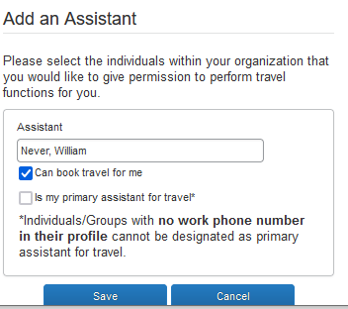

Once the assistant is listed on the Assistants and Travel Arrangers table, click the blue SAVE button to save these changes to your profile.

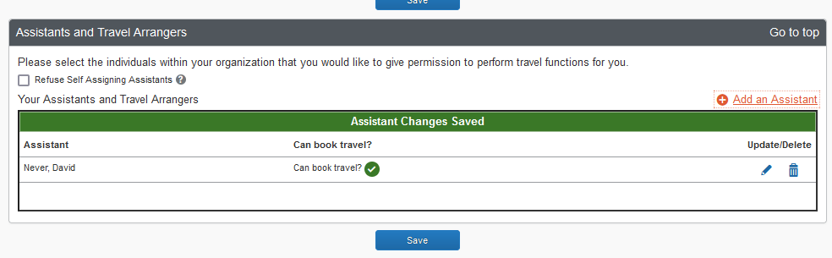

Concur –Assistant/Arranger instructions to book travel for another user:

Login as normal to your Concur profile at www.concursolutions.com
C on the PROFILE link on right
The select the option for "A Travel Arranger for any user (Self-assign)"
use the search box to search and select the traveler you need to book for.
Once selected, the traveler's name will now appear in GREEN at top right of page. You will now be assisting the user displayed. Changes to the PROFILE page and any RESERVATIONS will be applied to that user’s profile.

