WEX Card Instructions:
Prior to going to the pump:
- Ensure the License Plate Number of the vehicle matches the License Plate Number embossed on the WEX card.
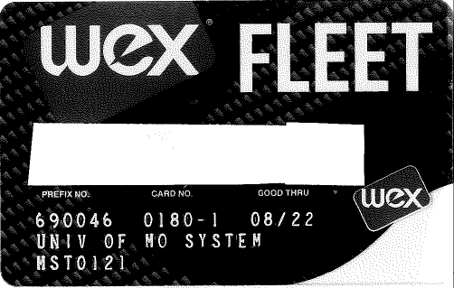
License Plate Number

- WEX Cards are vehicle specific – DO NOT use another vehicle’s WEX card to fuel another.
At the pump:
- Swipe the WEX Card
- Enter Driver Number (Pin) at the prompt
  - WEX pins are driver specific. They are randomly generated by employee number, employee first and last name, and department, and ARE NOT to be shared.
  - Dept. Driver pins will be supplied to student drivers by the WEX card Dept. custodian. The custodian will have a log requiring Student name, Current Odometer, Gallons purchased, and Total Cost. It is required to keep receipt and turn into WEX Custodian.
- Enter current odometer reading at the prompt
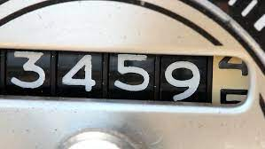
DO NOT include tenths
- Select fuel type and refuel as normal.

