NewsCentral User Guide
Welcome to NewsCentral. This guide will assist you in creating content, editing content, and managing user for your blog or newsletter. If you have any questions, please direct them to updates@umsystem.edu.

Accessing your NewsCentral site…………… ………….1
Posts………………………………………………………1
Writing your post……………………...…………1
Post options………………………….…………..2
Saving and publishing your posts………………..4
Pages……………………………………………………..5
Writing pages…………………………………….5
Page options……………………………………..6
Saving and publishing your pages………….……7
Content…………………………………………………..7
Formatting content………………………………7
Hand-Coded formatting………………………….8
Working with images…………………………………11
Adding images to posts and pages……………..11
Uploading image files to the server…...……….11
Positioning images in your content…...……….11
A note on image sizes………………………….13

Accessing your NewsCentral site

To access your site, please visit the URL that was given to you. All sites are related to the parent site: http://www.umsystem.edu/newscentral . Additionally, all sites have a development site, located at http://www-dev.umsystem.edu/newscentral/<yourSiteName> . Please use the development site as a playground to learn new features, or add test posts and entries.

To administer your site, add the wp-admin directory to the URL site. For example:
http://www.umsystem.edu/newscentral/yoursitename/wp-admin

Unless specified, logon with your University ID and password to access the site.

Posts

Writing Your Post

To create a new post, click on the POSTS link on the left-hand navigation toolbar.

You can choose ADD NEW, EDIT (to edit an existing post), or CATEGORIES (to create or edit categories).
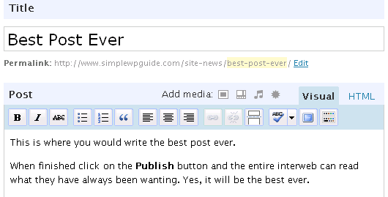
Give the Post a descriptive Title. This title will appear at the top of your post and will become the linked text that links to this post in other pages. It also becomes the default file name for the post unless you use the Permalink editing feature just below the title box to specify a specific name in the URL path.
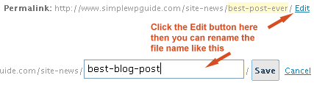
You can use the permalink editor to give the URL file-name a shorter version than the title of the post. If your post is titled “Best Blog Post Ever” the default URL to that page would be something like www.domain.com/best-blog-post-ever/ which is rather long. By editing the permalink name you could enter best blog post and the URL would then become www.domain.com/best-blog-post/
Write your content into the Post area. Use the editor icons to format your text.
Note: If you created your text using a word processor, like Microsoft Word, you will transfer lots of formatting when copying and pasting the text into the NewsCentral editor. It will produce a lot of unnecessary code. To avoid this, paste your text into a simple text editor like Notepad (all Microsoft operating systems include the Notepad program). This will strip all the formatting from Word into pure text. Then copy and paste from Notepad into the NewsCentral editor. You will now need to add your formatting as you would like it displayed on your website.
There is a button in the text editor options for pasting text from MS Word, but it is fickle and does not reformat everything. Your best option is to turn it into plain text, then reformat to with the editor buttons.

Post options
Below the text editor are a number of features and advanced options for your post. Here you assign things like categories, tags, allow or disallow comments, etc. Some of your options:
- 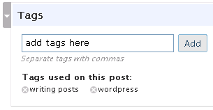
Tags - assigns tags to your Post. Tags are another form of categorization for your posts. If your WP theme displays tags then you may wish to use keywords related to the post in the Tags box; separate the keywords with commas. Note: tags are completely optional.
- 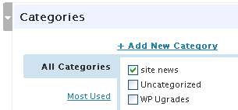
Categories - attach your post to a Category. You can add new Categories here. Categories can be also managed in the Manage/Categories tab. If you neglect to assign the post to a category, it will be assigned to your default category.
- Excerpt - you can use excerpts to write a brief description of the post. Some sites will display the excerpt on the main blog page, instead of the full post. The link to the post will then take the visitor to the full content. Use this if you know your theme is set up for using excerpts. This is an excellent feature to test in your development site.
- 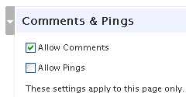
Comments and Pings - you may open a post to accept user comments or keep it closed to comments by selecting and un-selecting the check boxes. You can also set the comment defaults in the Options/Discussion Tab. The ping feature will display links to other blogs that have linked to your post. Note: comments and pings are completely optional.
- Password Protect this Post - you may make a post password protected using this option.
- Trackbacks - this would be used to manually ping another blog and notify you linked to them. This is for pinging older blog systems that do not automatically detect pings. Your best bet is to ignore this option, if applicable.
- Custom Fields - this is an advanced option that will not be covered here. You likely won’t need it.

Saving and publishing your Posts
As you write your posts, the editor will begin to auto-save your post as a draft. Use the Save or Publish buttons when you are ready.
Before publishing the post, you can use the Preview button to see how it will look first. Right click on the Preview button then open it in a new window or new tab so you can easily jump back to the write post page.
When you click the Publish button, your post will now be available for general viewing.

The little calendar option just above the Save and Publish buttons will allow you to post-date your blog posts. They will remain unpublished and then later go live on the site at your preset date and time. Click the edit link and those options will appear for you. If you wish to change the post order, adjust the Publish date; posts with more recent publish dates usually appear higher on your blog/newsletter.
Your drafts will not be published live onto the website until you select the Publish button. To edit draft posts you have not completed and published, click on the Manage tab. You will then find a full list of your posts It will indicate which are published and un-published. Click the Title link of your draft post to continue writing and then publish it.

Pages

Writing Pages
Pages are different from blog posts in that they are static pages outside the flow of updating posts. They often form the main navigation to sections of your site that tend not to change. These can be as basic as an About Us page or a Contact Page, or it could include a whole series of articles and sub-pages that reside off of higher order pages in your sites navigation structure.
Writing a page is similar to writing a post. After Clicking the Write tab click on the Pages tab.
Again, like writing a post, you give your page a title. This title will appear at the top of your page as the headline. It also becomes the default file name for the page unless you use the Permalink editing feature just below the title box to specify a specific, perhaps shorter, file-name in the URL path.
You can use the permalink editor to give the URL file-name a shorter version than the title of the page. You can also use it to cover different variations on your keywords for that page. At times, this can help with your search engine traffic.
Then, write your content inside the text editor. Use the graphic editing icons to format your text.

Page options
Below the text editor are a number of options. Pages have some different options to choose from than posts, with some the same too. We highlight the main ones you would be using by adding a screenshot image of that feature.
- 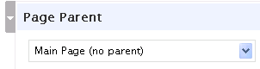
Page Parent - select from current list of pages where this page should lie in relation to others. This sets the hierarchy of pages and sub-pages within the navigation structure of your website.

Saving and publishing your Pages
Publishing and saving pages is similar to publishing and saving posts.

Content

Formatting Content
When writing a post, or a page, in the text editor you simply type your text. The basic paragraph formatting will create itself as you hit the enter key at the end of each paragraph.
For formatting of your text, please use the graphic editing icons at the top of the text editor.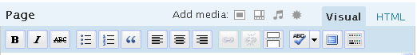
These icons will cover many of the basic formatting functions that you will need to use.

Using the Editing Icons
For most of these icons you would select (click and drag with your mouse) your block of text you wish to apply it to; then, click the icon to apply the formatting. Other tools, like inserting images, require that you just click on the area of the content you wish to place the image; then, click the icon and enter the information in the pop-up. The steps are similar to using any word processor, such as Microsoft Word.
Icon descriptions:
Bold - select an area of text and click the bold icon
Italics - select a block of text and click the italic icon
Strike Through - Adds a line over your text through your text
Unordered List - creates bullet lists
Ordered Lists - instead of bullets it will auto-number your chosen list
Outdent - undo an indent
Indent - indent a section of text to create block quotes
Align Left - aligns text to the left
Align Center - centers your text
Align Right - aligns text to the right
Add Hyperlink - select the area of text you wish to be the link and click the link icon. Add the link URL. Then, choose if you want it to open in a new window or the same window. You should then assign a title.
Remove Hyperlink - use this to remove a link
Split Post - inserts the <!–more–> tag to split your post. This shows just a brief intro on your main blog page with a link to the full post where they can read the rest.
Spell Check - spell checks your text. For on-the-fly spell checking, we recommend using FireFox as your web browser. It has built in spell checking for any text you enter into forms online. I can also underline misspelled words in red as they are typed.
Help – The help menu can assist with some basic editing questions.
Advanced Tool Bar - This icon will open the icons outlined below.
Formatting - Use this drop down to select your heading levels. No need to use the paragraph one as Wordpress will turn your basic text into paragraphs automatically
Underline - underline text with this icon
Font Color - change color of a selection of your text
Paste as Plain Text - to paste text copied from another source so as to strip all formatting from the copied source
Paste from Word - to paste from a Word doc and remove the unneeded formatting codes that Word will try to add
Remove formatting - to remove formatting for a selection of text, perhaps cut and pasted from another source
Insert Embedded Media - insert multimedia files, such as video clips
Insert Character - for adding special characters not available on your keyboard, such as ¥, £, ©, Æ, or é
Undo - undo your last change
Redo - redo your last undo

Hand-Coded formatting
Should you need to use any HTML (Hyper Text Markup Language) coding not covered by the visual editor button, you can use the Code view to hand-code your page. This requires some basic knowledge of HTML tags which may be beyond the capabilities of many users of this guide.
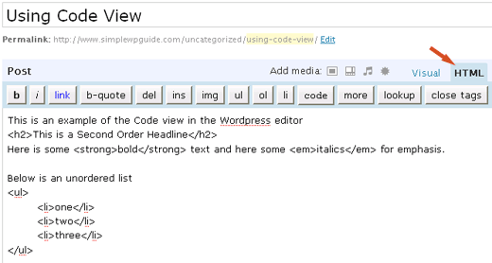

Working with Images
Adding images is relatively easy using the image upload feature in the post or page editor.
Be sure to read the “Note on Image Sizes” at the bottom of this page. It’s quite important.

Adding Images to Posts and Pages
First have your cursor set at the spot in your post, or page, where you want the image to appear. Following the steps below will paste the image code at that spot in your editor.
Should you want to move the image to another location within the body of your text, an easy way is to switch to HTML view, find the portion of code for that image, and then copy, cut or paste it to the new location, inside the text, while in HTML view.

Uploading Image files to the server
Click the “Add an Image” icon in the Add Media section above the editor buttons.
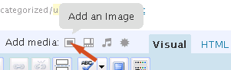
Then, go and hunt for your image file on your computer and hit the upload button.
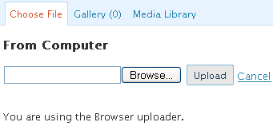

Positioning Images in your Content
Use the alignment options to choose the horizontal alignment for the image. For example, choosing left alignment will force the image to the left of the content area.
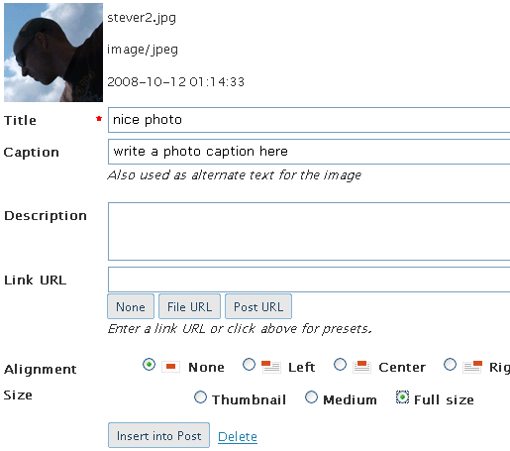
Give the Image a title. By default, it will use the file name, but you can change it. You may add a caption that will appear below the image. If you do not want a descriptive caption to appear below your image, leave the caption blank.
You can choose to have the image link to something. This can be very handy if you want to upload a large image. You can have a smaller sized on inside your post but have it link to a larger version that is stored on another site. Visitors can then click the link to view a full sized image without breaking the layout of your site.
You can set the alignment of the image and how text will wrap around it, or not wrap around it.
You may also set some size constraints on your image. When you upload an image using the image uploader , it also creates a small thumbnail file of the image. You may choose to just display just the thumbnail in the post.
Click the “Insert Into Post” button to add the image to your post.

A note on Image sizes
Images on your computer are sized in pixels. The space you have to place an image inside a post or page is limited to the width, in pixels, that the content area of your site allows. If the size of your image extends beyond the width of the content area, it can alter the layout of your site and force your sidebar to the bottom of the page.
Typically, many sites are designed to be 800 pixels wide (the width of a 15″ monitor). Now that more internet users are now using 17″ and bigger monitors some sites are going wider than just 800px. Your sidebar may take up 200 to 300 pixels. There may be some padding around your content area, and you may be left with an effective width of 500 to 600 pixels to work with.
You should strive to keep you images to a size of less than 300 – 400 pixels of width. To do this, open the image file in the editor, crop the image to your desired viewpoint, and reset the image dimensions. Now, re-save the image.

Please let us know if you have any questions. We can be reached at updates@umsystem.edu .

