Introduction to Academic Advising at the University of Missouri
Module 1: Introduction to Advising

- Introduction

- Module Objectives/Guiding Questions
Welcome to Module 1: Introduction to academic advising
You should be able to answer these questions by the end of this lesson.
Questions 1 – What is academic advising?
Question 2 – What is the history of academic advising?
Question 3 – What are some of the common approaches to academic advising?
Question 4 – What are some of the organizational models of advising?

Keep these in mind as you complete this module.
- What is Academic Advising?
At first glance, this might seem like a silly question. Even if you have not studied academic advising, having gone to college, you had at least some experience with an advisor. You know what advisors do. Right? Sure. . .but even among experienced advisors, there is not one standard definition for academic advising.
This is because various approaches characterize the advising relationship in very different ways. We will explore some of these approaches later in this module. Regardless of the approach, the basic purpose of academic advising is to help students navigate the institution in order to achieve their educational goals.
Academic advisors may also address personal, social, and emotional concerns as they relate to educational goals. According to the National Academic Advising Association (NACADA), this is done by establishing a teaching and learning relationship that is collaborative and focused on growth.
Next we will look at some national perspectives as well as how the UM System describes academic advising.
- NACADA Core Values
Because there is not one set definition of academic advising, we will start by looking at how the UM system as well as some national voices describe the role of the academic advisor.
NACADA is an association of faculty, students, staff, and administrators who are interested in promoting quality academic advising. Members of NACADA contributed to the development of a statement of core values. These are meant to represent academic advising as a profession.
These values should guide your advising practice regardless of the approach you may choose. At times it may not be possible to balance all of these values given the specifics of a situation.
When you are facing such a dilemma, it is a good idea to consult with other advisors. We will talk in more depth about NACADA Core Values in Module 4 which addresses legal and ethical issues.
https://www.nacada.ksu.edu/Resources/Pillars/CoreValues.aspx

NACADA core values are:
- Caring
- Commitment
- Empowerment
- Inclusivity
- Integrity
- Professionalism
- Respect

- CAS Standards
The Council for the Advancement of Standards in Higher Education (CAS) is a consortium of 42 higher education student programs and services organizations. CAS members work together to develop best practice guidelines for the development, assessment, and improvement of quality student learning, programs, and services”. (CAS, 2015).
NACADA – the advising professional organization- is a member of CAS which has developed a set of standards for academic advising programs. You will learn about relevant portions of CAS Advising Standards throughout modules 1-5.
Getting back to the question of just what is academic advising, according to CAS standards, the “mission of Academic Advising Programs (AAP) is to assist students as they define, plan, and achieve their educational goals”. An academic advising program must advocate for student success and persistence. In addition, CAS standards state that the mission of the academic advising program must be consistent with the mission, structure and resources of the institution. We will discuss the relationship between academic advising and institutional mission in more detail in Module 2.
According to CAS Standards Academic Advising Programs (AAP) meet their mission by contributing to four areas which are

formal education including both the curriculum and co-curriculum

student progression and timely completion of educational goals

preparation of students for their careers, citizenship, and lives

student learning and development

CAS further details six ways that academic advising programs contribute to student learning and development. You can explore these by clicking through the pages to the right. (below)

Ways advising programs contribute to student learning and development:

identify relevant and desirable student learning and development outcomes

articulate how the student learning and development outcomes align with the six CAS student learning and development domains and related dimensions

assess relevant and desirable student learning and development

provide evidence of impact on outcomes

articulate contributions to or support of student learning and development in the domains not specifically assessed

use evidence gathered to create strategies for improvement of programs and services

As we just learned, advising programs must contribute to student learning and development. According to CAS, this includes knowledge, cognitive complexity, intrapersonal development, interpersonal competence, humanitarian and civic engagement and practical competence. Please explore the learning and development domains and their associated dimensions that are outlined in the CAS Standards.
Domain | Dimensions
knowledge (acquisition, integration, construction, and application) | understanding knowledge from a range of disciplines; connecting knowledge to other knowledge, ideas, and experiences; constructing knowledge; and relating knowledge to daily life
cognitive complexity | critical thinking, reflective thinking, effective reasoning, and creativity
intrapersonal development | realistic self-appraisal, self-understanding, and self-respect; identity development; commitment to ethics and integrity; and spiritual awareness
interpersonal competence | meaningful relationships, interdependence, collaboration, and effective leadership
humanitarianism and civic engagement | understanding and appreciation of cultural and human differences, social responsibility, global perspective, and sense of civic responsibility
practical competence | pursuing goals, communicating effectively, technical competence, managing personal affairs, managing career development, demonstrating professionalism, maintaining health and wellness, and living a purposeful and satisfying life

- UM System Academic Advising Competency Model
What brought you to academic advising? Maybe you have a story about a high school guidance counselor, coach, or teacher that really took an interest in you OR a faculty or professional advisor that really helped you through your undergraduate years. What were the personal and professional qualities that this person demonstrated? If you look closely at the University of MO System’s Academic Advising Competencies, you are likely to see some of the same qualities that inspired you.
The University of Missouri Academic Advising Competency model was developed by academic advising leadership across all four UM System Universities. These are the competencies that you are expected to develop and maintain. The competencies are based on best practices identified in academic advising literature, the NACADA core competencies, and the Council for the Advancement of Standards in Higher Education (CAS) Academic Advising standards.
These six competencies reflect the different roles you will play as an advisor. They are humanizing agent, counselor, educator, collaborator, developer, and innovator. Each competency emphasizes a different aspect of your role.
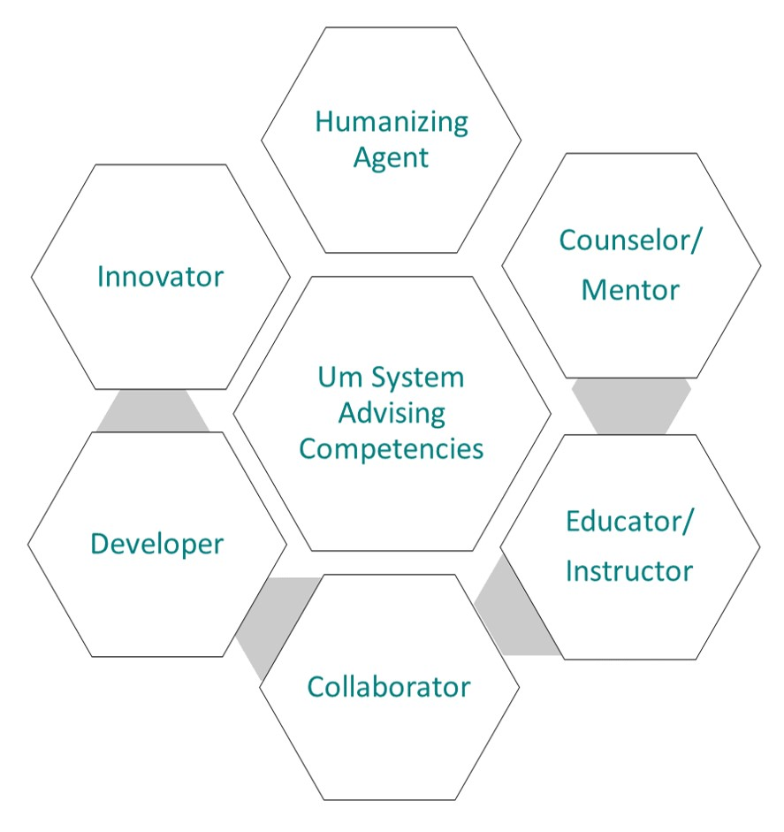

Behavioral anchors for each competency describe adequate performance of the associated competency. For example, the Counselor/Mentor competency requires you to provide guidance with regards to students’ developmental issues (for example, academic transitions, time management and study habits, career planning, and work/life balance) and to refer students to appropriate campus resources for assistance.
Over the next several slide you will explore the description and associated behavioral anchors for each competency role.
The behavioral anchors can help you and your supervisor set professional goals. Although there are many different paths to a career in academic advising, at the core this position is about helping students and the more competent you become, the more students will benefit.
We will provide information about the learning objectives and the competencies addressed in each module. As you can see, this module focuses on the counselor/mentor role. If you click the hotspots to the right, you will also see the associated behavioral anchors specifically addressed. (next)
Humanizing Agent
Makes oneself available and accessible to students and campus community members, interacting with them in such a way that they feel comfortable, at ease, and that their concerns are valued.
- Creates a positive environment for students with diverse backgrounds that can include different ethnic, racial, domestic, and international communities; sexual orientations; ages; gender and gender identities; physical, emotional, and psychological abilities; political, religious, and educational beliefs.
- Takes the initiative to reach out to and meet with current and prospective students as well as other campus community members.
- Creates a positive environment for students by welcoming them upon arrival. Shows interest in, and genuine care for, students’ concerns by building positive rapport.
- Actively listens by giving full attention to what others are saying; takes the time to understand what is being said; restates what was said by the student to ensure understanding as necessary; asks questions as appropriate and avoids interruptions.
- Communicates information and ideas in speaking so that others will understand, verifying comprehension of what was said.
- Deals calmly and effectively with high stress situations; maintains composure and keeps emotions in check even in very difficult situations.
- Determines that students’ needs have been met, confirms next steps, and provides follow-up contact information. Takes the initiative to reach out to students who may benefit from additional follow-up.
Counselor/Mentor
Helps students develop strategies for success and guides students’ decision making.

- Through a collaborative process with students, assesses educational and career objectives. Fosters personal initiative and responsibility, by encouraging problem solving, critical thinking, and decision-making, to facilitate their meeting of these objectives.
- Provides guidance with regards to student development issues (e.g., academic transitions, time management and study habits, career planning, and work/life balance), referring students to appropriate campus resources for assistance. Follows up with students as needed.
- Addresses student concerns with regards to scholastic and probationary problems, utilizing campus resource referrals as necessary.

Educator/Instructor
Demonstrates knowledge of, and educates students and other campus community members on, academic programs, policies and procedures.
- Takes a leadership role in orientations and presents academic information to new and transfer students.
- Reviews transcripts for equivalencies and application to degree programs, utilizing available campus resources and technologies, to maximize student credits while eliminating enrollment errors.
- Educates students on general education and degree requirements. Supports students with course registration, schedule planning and adjustments, while eliminating advising errors.
- Interprets and explains college and university policies and procedures to students and/or families, seeking out additional information from other sources as necessary.
- Maintains accurate and complete student records; monitors and updates degree audits.
- Prepares and monitors graduation lists; determines eligibility and satisfactory progress toward degree; follows up with students regarding necessary adjustments to graduation plans; takes the initiative to identify and reach out to eligible students who have not applied for graduation.
Collaborator
Effectively collaborates with others both within the office and across campus.
- Understands and is committed to achieving team goals within the office; sacrifices individual objectives in order to achieve group objectives.
- Interacts and collaborates with student support offices (e.g., Admissions, Financial Aid, Disability Access Services, Health and Wellness Services, Multicultural Relations, Career Services, Retention Services, and Tutoring) to ensure student success. Seeks out opportunities to learn more about, and strengthen relationships with, student support offices.
- Seeks out and confers with faculty, administrators, and other professionals to discuss students’ progress, resolve academic problems, and to determine priorities for students and their resource needs.
- Takes part in recruitment events and actively seeks out various outreach opportunities (e.g., campus committees, satellite advising).
- Demonstrates engagement in problem solving and decision-making through proactive participation.
Developer
Actively seeks out learning opportunities to better oneself, both as an individual and as a professional.
- Participates in organized and self-directed professional development activities (e.g., meetings, educational conferences, training workshops), proactively seeking out such opportunities.
- Demonstrates initiative by proactively seeking out, volunteering for, and taking on new responsibilities and challenges.
- Demonstrates innovation and creativity by thinking about things differently and developing novel and useful ideas that have the potential of positively impacting the office.
- Responds positively to change, is open to new ideas and approaches, and adapts to new situations. Helps others recognize the benefits of change.
- Views situations with unfavorable outcomes as opportunities to learn, grow, and develop for both one’s self and for others.
- Takes responsibility for individual self-reflection and assessment, documenting evidence of strengths and developmental areas.
Innovator
Demonstrates knowledge & implementation of technology tools & resources and educates students on use of technology to support academic success.
- Consistently utilizes technology tools and resources to track and support student success.
- Consistently promotes student use of technology tools and resources to foster personal initiative and responsibility.
- Responds positively to opportunities for increased intervention in student progress provided by technology tools and resources (i.e. Early Alert, SSC Platform).
- Activities

- Read the UM System Academic Advisor Competency model. How do they apply to your work? Ask a supervisor for clarification.
- If you have not received it yet, ask your supervisor for the criteria they will use to evaluate your performance.
- Write a short statement about how you would like to improve in 3-4 of the behavioral anchors. For example:

Statement: Through a collaborative process with students, assesses educational and career objectives. Fosters personal initiative and responsibility, by encouraging problem solving, critical thinking, and decision-making, to facilitate their meeting of these objectives.
Plan: I realize that I need to know more about decision-making. I will read 2 articles a week for the next two months to improve my understanding of decision-making theories and I will identify tools that may help my students.

- The Evolution of Academic Advising
- Introduction
Next we will look briefly at the history of academic advising. We will also look at a couple of factors currently influencing your work including the professionalization of advising and the entry of Generation Z into higher education.
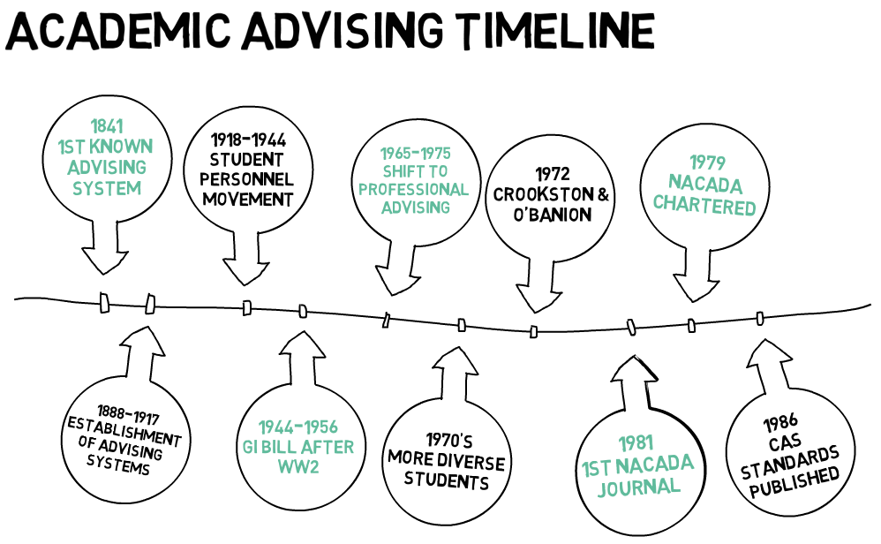
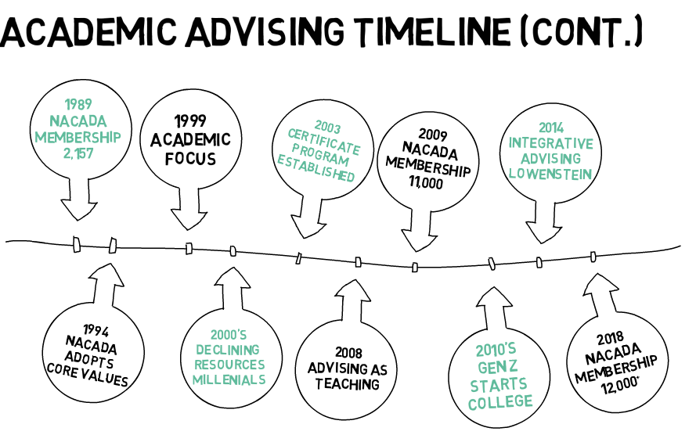

- Timeline
The field of academic advising has developed greatly in the last 80 years - from the first known advising system in 1841 to our newest generation entering higher education. Learning about major milestones helps us to understand the development of the field of academic advising. It also gives us some insight into where things might be heading. Explore the timeline below to learn more. There is also a handout with more detail in the resources section at the end of the module.
Date | Milestone
1841 | First known system of advising – paired each student with a faculty and used the term "advisor" (Kenyon College, Ohio)
1888-1917 | Establishment of advising systems, extended orientations begin to be offered
1918-1944 | Student personnel movement gained momentum - advising practices start to become more differentiated
1944-1956 | After World War 2, GI bill leads to new services and more studies about advising  [Wilensky Stage 1]
1965-1975 | Largest shift from faculty advising to advising as a specialized role – this involved differentiating academic advising from other activities such as counseling
1970’s | Open access policies, increase in community colleges, and access to financial aid meant a more diverse group of students began seeking higher education. This included more first-generation college students, more students with few financial resources, adult students, and students with disabilities.
1972 | Crookston and O’Banion each wrote seminar articles defining and describing academic advising. Both articulated a developmental perspective that was in contrast to the more traditional perspective which was more prescriptive.
1977 | First national conference on academic advising held in Burlington, VT
1979 | National Academic Advising Association (NACADA) chartered with 492 members – a key step toward professionalization  [Wilensky Stage 3]
1981 | The first issue of the NACADA journal was published
1983 | Habley identified seven organizational models: faculty only, supplementary, split, dual, total intake, satellite, and self-contained
1986 | Council for Advancement of Higher Education Standards (CAS) publishes standards for student services/development programs including academic advising
1989 | NACADA membership 2,157
1994 | NACADA formally adopts a statement of Core Values  [Wilensky Stage 4]
1994 | O’Banion states that developmental and prescriptive approached can both be useful depending on circumstances
1999 | NACADA membership 5,318
1999 | Some call for a shift from developmental to more academically focused approaches to advising (Hemwall & Trachte; Lowenstein)
2000’s | Higher education faced declining resources while also experiencing enrollment pressure and calls for greater accountability. Millennials begin attending.
2003 | Certificate program in Academic Advising established – collaboration between Kansas State University and NACADA [Wilensky Stage 2]
2008 | Masters in Academic Advising program established – collaboration between Kansas State University and NACADA
2008 | Developing views of academic advising as a form of teaching (Appleby, Campbell & McNutt)
2009 | NACADA membership 11,000
2010’s | Late 2010’s Generation Z begins pursuing higher education
2014 | Lowenstein offers a Theory of Integrative Advising
2018 | NACADA membership 12,000+
01/01/2019 | Academic advising in the process of professionalization

Links to additional information:
- Crookston (1972) – Advocated a move from prescriptive to developmental philosophy of advising that centered that student rather than simply focusing on picking and scheduling courses. His approach focused on building a relationship and considered the whole student. In addition to course related tasks, Crookston’s approach helped students to increase skills such as decision-making and problem-solving in order to move them toward academic, career and personal goals.
O’Banion (1972) emphasized a relationship in which an advisor served as a guide and teacher. He outlines a five-step advising process to promote student development that included exploring life goals, exploring vocational goals, program choice, course choice and scheduling choice.

- Lowenstein (2014) offers a Theory of Integrative Advising
Academic Advising
- is an academic endeavor with a purpose specific to higher education.
- enhances learning and is a source of learning unto itself.
- provides an opportunity for integrative learning – in other words it helps the student to make sense of their whole educational experience.
- views the students as an active participant – the student constructs and the advisor facilitates.
- is transformative NOT transactional.
- is central to the achievement of institutional goals.

- Professionalization

Slide 1:
Although some argue otherwise, many leaders within the field agree that academic advising is still in the process of becoming a profession – also known as professionalization.

Scholars point to some specific characteristics that distinguish a profession from an occupation. These primarily focus upon the knowledge and governance of those practicing the occupation.

Members of a profession have a complex set of knowledge and skills that require significant specialized training. You must have this training in order to enter the profession. This training forms a basis for entry into the profession. Professionals are self-governed by a set of rules/codes that have been developed by members. In other words, members of the profession make sure all practitioners are following the establish code of conduct. Professionals organize into associations for purposes of advancing the profession.

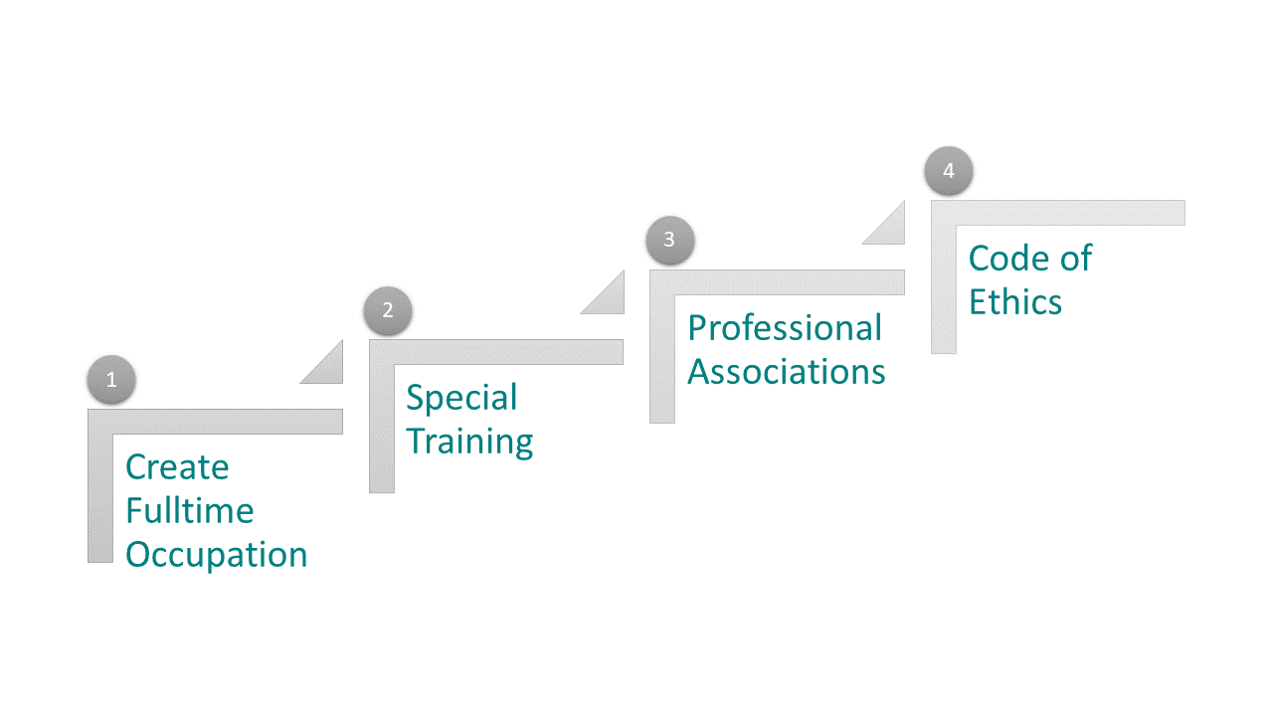

Wilensky (1964) offers a theory to explain the progression of an occupation into a profession:
Stage 1: Create a full-time occupation
Stage 2: Establish tools and specialized training for the occupation
Stage 3: Develop professional associations around the occupation
Stage 4: Develop a code of ethics

A recent study of NACADA leadership shows that even they do not agree on the status of advising as a profession or if achieving professionalization is even something to strive for. As an advisor, you probably want to keep an eye on this evolving story.

Since the beginning of higher education, students have needed mentors to help provide guidance. However, the opportunities to select electives and make choices about tracts and such is a newer development. Having more choices meant students needed a little more guidance in terms of decision-making and course selection.

Originally this guidance came from faculty members, but as faculty members faced more pressure to produce scholarship and increased teaching loads it became harder for them to devote as much time to this task of guidance. To help alleviate some of this pressure, colleges started having staff members do a portion of this guidance. We can trace academic advising to these beginnings. As you can see,

Academic advising did not progress through the stages in the order outlined by Wilensky. Click each of the hot spots below to learn a little more about milestones in the progression of academic advising as a profession.

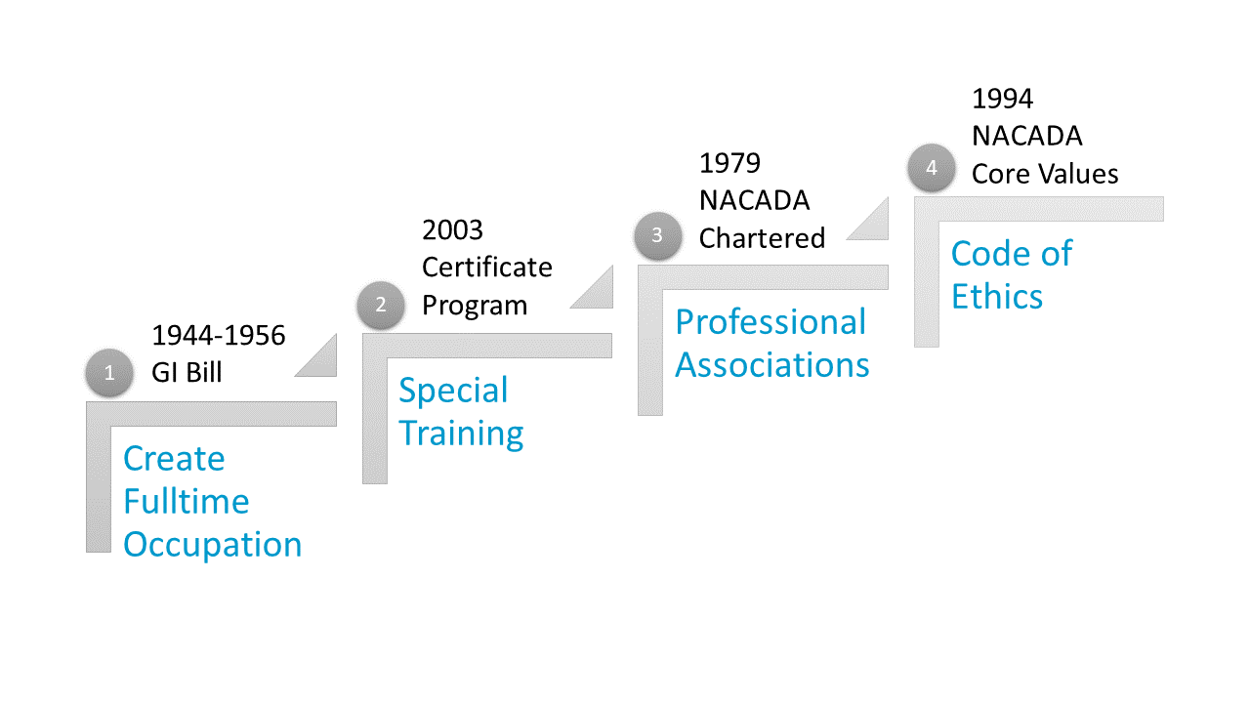

Spot 1
After World War II, many soldiers took advantage of the GI Bill. Soldiers had different needs than previous generations of students which lead to many new services being offered. Throughout the mid-1960’s to mid-1970’s academic advising became differentiated from other forms of student services such as counseling or psychological services.
Spot 2
And in 2003, Kansas State University began offering a certificate in academic advising in collaboration with NACADA. In 2008, that same program began offering a master’s degree.
Spot 3
In the late 1970’s the National Academic Advisors Association was chartered with close to 500 members. NACADA has continued to grow and has approximately 12,000 members at this time.
Spot 4
In the early 1990’s NACADA developed Core Values to guide its members.

- Generation Z
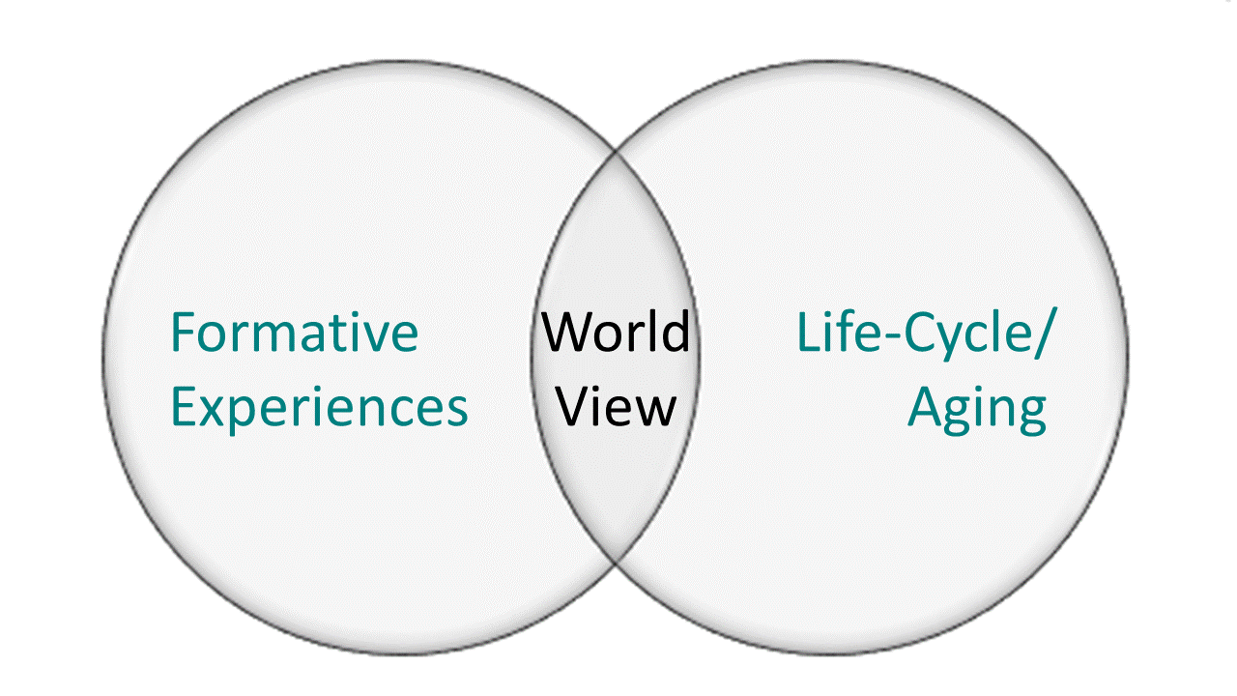
Generations are cohorts of people who, because they were born around the same time, have had many of the same experiences. According to Michael Dimlock of Pew Research Center, generational cohorts “can provide a way to understand how different formative experiences (such as world events and technological, economic and social shifts) interact with the life-cycle and aging process to shape people’s views of the world.” You have probably seen a lot of information about Millennials and may be one yourself. We are now seeing the first members of the Post-Millennial or Generation Z enter higher education. Next, we will learn a little about this cohort and how this information can help you advise Gen Z students.

Generation Z

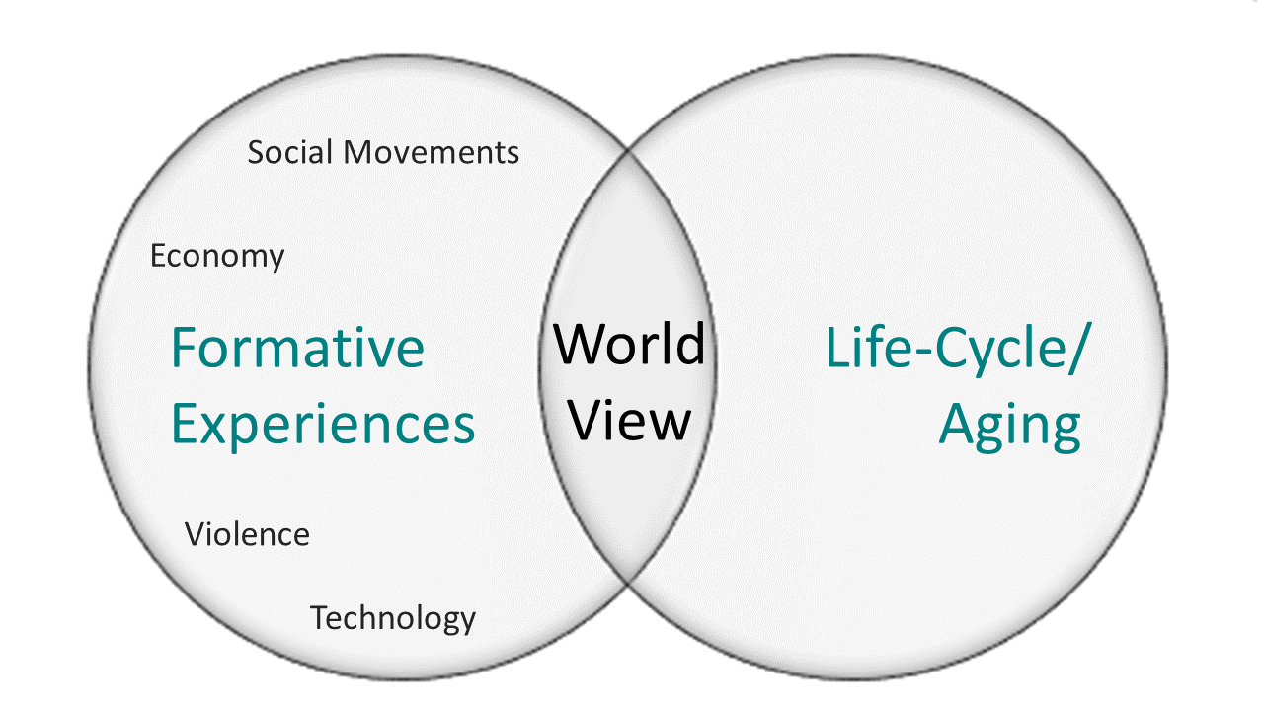

Although there is some disagreement on the beginning and end dates for Generation Z, a good rule of thumb is those born from the mid-1990’s to early 2010’s. This generation has been shaped by witnessing violence (mass shootings), a volatile economy (the great recession), social movements (Black Lives Matter, gay marriage rights, and others), and great advances in technology (from the first DVD in 1996 to smart phones and growth of social media). This generation has had access to information beyond any generation before them, but they have also witnessed instability that has made them cautious. We are going to present some characteristics of Post-Millennials that might help as you work with this next generation of students, however, it is important to remember that students are individuals. This information simply gives you some context. Your best bet is to get to know each student.

Characteristics of Post-Millennials:
Again, these characteristics are meant to provide you with some general guidelines and will not likely apply in whole to any individual student. That being said, here are some things to consider.

- Many Post-Millennials prefer to learn visually – they like to see something done correctly before they try to do it themselves. Many regularly watch videos of others first when wanting to learn a new skill.
- They prefer hands-on learning, however, really want to apply concepts they are learning to a new problem.
- Many prefer to think through concepts and problems on their own before working with others which is different that Millennials who prefer collaborative and team-oriented learning.
- Focused on social justice for all people, they see their generation as capable of making real and important changes.
- Deep engagement and the opportunity to make a real change are preferred over less involved volunteer opportunities.
- And having grown up in the gig economy, many see themselves as innovators and want to work for themselves, however, they value meaningful work over making a lot of money.

Since GenZ has only recently started attending, it is safe to assume that most programs have been developed and built with previous generations in mind. It will be interesting to see how the needs and preferences of this new generation shape higher education.

Here are four tips that campuses can follow to effectively engage with Generation Z. These include using videos and other visuals, incorporating interapersonal learning, providing opportunities to address social needs, and practical learning opportunities. Flip the cards below to reveal questions to help you think about how you can use these tips in your own advising practice.

Tips:
- Use videos and other visuals – Gen Z are interested in learning through observation. You can even do this with your advising processes. Are there ways you could show your processes visually?
- Incorporate intrapersonal learning – provide students with opportunities to reflect on concepts and problems before discussing with a group. This works particularly well with a flipped design where the student does an activity in preparation for learning rather than after. Can you provide students simple “things to think about/reflect on” prior to advising appointments?
- Offer opportunities to address social needs as a community – Are there social issues related to your students’ field of study? Is there a way you could help facilitate involvement – particularly if they might be able to work with individuals already working in the field?
- Make connections to internships – practical learning opportunities are important to this generation and they do not want to wait until they are advanced in their studies. How can you develop opportunities for practical learning that are appropriate for less experienced students?

- Activity
Activities
Think about ways you might adjust your work to accommodate the preferences of Gen X/Post-Millennial students. Share your thoughts with your supervisor.
- Find out as much as you can about practical learning experiences that are available for your students - especially for students without much prior experience.
- Think of two common reasons that students come for advising. Develop some questions and pre-work that you can send to students prior to these appointments.
- Review your advising materials. Are there ways you could adjust your advising materials to show your processes visually?
- Talk to others in your department to identify social issues related to your students’ field of study. Are other students and faculty already taking action to address these issues? Keep these opportunities in mind for your students.
- Advising Approaches
Now we will turn to advising approaches. These approaches are informed by cognitive, psychological, and psychosocial theories. We will learn more about these foundational theories in Module 3. Although there are numerous approaches to academic advising, in this module we will focus on Prescriptive, Developmental, Intrusive, Strength based, Social Constructivist, and Learning-Centered Approaches.
As you learn about the different approaches, one may resonate with you more than others. There is not one “right” approach and as you gain experience, you will develop your own style.
You will also have to consider the circumstance as well as the individual student’s preferences and comfort level when choosing an approach. It is standard practice to pull from several different approaches, so it is important to learn about what each has to offer.
The two most common approaches are Prescriptive and Developmental which were first described by Crookston in 1972. The Prescriptive Approach to advising is a traditional approach in which the advisor acts as an authority. It is often characterized as focused upon the more administrative parts of advising such as registration, course selection, and providing information about processes. The student has a problem and the advisor presents a solution. This type of advising is sometimes compared to the doctor/patient relationship. The student is expected to follow the advisor’s “prescription”. This approach is narrowly focused on specific questions and is usually initiated by the student; however, the interaction is passive for the student in that the advisor provides solutions and the student receives the advice and is expected to take it. Ultimately, the solution is the advisor’s responsibility.

Student: How many classes should I take next semester?
Advisor: After checking your transcripts, you have 25 hours left to graduate. I recommend you take five classes this semester and 4 next.

The Developmental Approach to advising is focused on students’ growth and development. It is concerned with specific personal and vocational decisions but takes a more holistic approach by also considering the development of critical thinking skills, interpersonal interactions, and awareness of one’s own behavior. With this approach, the advisor provides information and guidance, but the decision is the student’s to make. O’Banion (1994) suggests five dimensions for Developmental Advising which are 1) explore life goals, 2) explore vocational goals, 3) program choice, 4) course choice, and 5) scheduling choice. Prescriptive and Developmental approaches are often pitted against each other in the literature; however, keep in mind that sometimes prescriptive approaches can build a foundation for more developmental tasks.

Student: How many classes should I take next semester?
Advisor: What are your goals? When do you want to graduate?

The developmental approach has been criticized by some for emphasizing development over education. One alternative offered is the Learning-Centered Approach which focuses on the advisor and students’ reciprocal relationship of teaching and learning. This approach emphasizes self-transformation rather than self-actualization or self-development and discourages students from seeing courses simply as requirements to check off. Instead it encourages students to consider the relationship of knowledge gained from each course and between courses.

Proponents say the focus on learning connects advising more securely to the education mission of the institution.

Student: How many classes should I take next semester?
Advisor: Let’s talk about what you have taken so far and how you might build on that.

The Intrusive Approach is also sometimes called the Proactive Approach. With this approach, the advisor initiates contact with the students. Unlike the prescriptive approach, there is an emphasis on relationship building and focus on a broader range of needs.

Contact is made at key times in order to provide support in order to help build resilience. This approach can be especially helpful for students that are struggling or that do not typically utilize advising services. Because this approach is proactive and relationship focused, it can help to increase students’ sense of belonging.

Advisor: Registration is coming up. Come in next week so we can talk about what classes you might take.
Student: Okay.

The Strength Based Approach focuses on a student’s areas of talent and builds upon them. The advisor identifies strengths and teaches students how to apply their strengths to new situations. This approach is good for building confidence and motivation. A related approach is Appreciative Inquiry which uses open-ended questions to discover strengths, abilities and skills. Schreiner suggests these five steps:
Step 1: Identify Students’ Talents
Step 2: Affirm Students’ Talents and Increase Awareness of Strengths
Step 3: Envision the Future
Step 4: Plan Specific Steps for Students to Reach Goals
Step 5: Apply Students’ Strengths to Challenge areas

Student: How many classes should I take next semester?
Advisor: What kinds of courses do you tend to do well in or enjoy most?

Social Constructive Approaches are collaborative and involve “educational planning and institutional services . . . created by collaborative social interaction” This approach may be good for groups that value community over individual achievement. Learning occurs through social context and interactive dialogues. Although academic advising is almost always conceptualized as a one to one activity, this new way of thinking may mean that some advising activities happen in the context of pairs or small groups.

Student: Tyce and I want to know how many classes we should take next semester?
Advisor: Tell me what you are thinking about.
Student: Well, Tyce really did well in cell bio, so I was thinking of taking that next semester for sure.
Advisor: OK. So Tyce, can you tell us a little about the aspects of cell bio that you really enjoyed?

Comparing Advising Approaches

 | Prescriptive | Developmental | Learning -Centered | Intrusive/ Proactive | Strength-based | Social Constructivism
Advisor Role | Authority | Guide/Partner | Teacher | Initiate contact | Coach | Facilitator
Student Role | Recipient of information | Active partner | Active learner | Act on information | Draws on experience as scaffolding | Member of learning community
Goals of Encounter | Task Completion – registration, course selection, provide information | Personal Growth- academic, career, personal  Whole student | Make meaning and connections between educational experiences | Motivating students to seek help when needed | Builds on inherent talents | Use collaborative and social approaches to make decisions and explore academic options
Application | Prescriptive can be used to build a foundation for more developmental focus later. | Concerned with personal & vocational decisions but also about facilitating problem-solving and rational processes (Crookston) | Emphasizes the importance of students understanding the institutional mission and how it relates to their own academic goals. | Can be helpful for persistence, especially for struggling students. | Can increase motivation & confidence. Related to appreciative inquiry. | Might work better for those coming from cultures that value relationships over individual achievement.

- Advising Organizational Models
Academic advising models differ from institution to institution. These models can be categorized based on location and by who is providing advising services.

First let’s talk about location. By location we mean, where do advising services lie within the overall institutional structure?

- Centralized advising models locate professional and faculty advisors in one academic or administrative unit.

- Decentralized models locate professional or faculty advisors in their respective academic departments.

- Shared models locate some advisors in a central administrative unit while others advise students in the academic department of their major discipline.

In addition to the location, advising models can also be categorized based on who is responsible for providing services . . . faculty or professional staff advisors.

The Self-Contained Model is a centralized model. ALL advising occurs in one location for all students regardless of their major – this can be either an advising center or a counseling center. These are primarily staffed by professional advisors or counselors; however, faculty may also advise at the center.

The Faculty Only Model has a decentralized structure in which all advising is done by faculty members – most often from the student's academic discipline. This model is used by more than half of all private bachelors classified institutions.

There are several academic advising models that have a shared structure. Those include the Supplementary, Split, and Dual models.

Institutions using the Supplemental Model assign students to a department advisor that signs off on all advising decision. This faculty advisor receives support from a central administrative advising unit with professional staff that can provide training, degree audits, and other resources.

The Split Model is similar to the Supplemental Model in that advising is shared among faculty and a center of professional advising staff. However, with the Split Model, staff usually handle advising until students have met certain requirements. For example (undecided, freshmen, or those on academic probation would be advised by staff advisors until they have met certain requirements. Once met, they are reassigned to advisors in the school or department that offers their major. The Split Model is use by more than half of 4-year public colleges and universities.

The Dual Model also features two advisors. One is an instructional faculty who advises students on matters related to the major and one is from an advising office and focuses on general requirements, procedures, and policies. Unlike the Supplemental Model in which the faculty advisor is the primary advisor, with the Dual Model, both advisors share responsibility although for different aspects of academic advising.

Shared split and self-contained are the most common models – being used by about 80% of all institutions. Self-contained is the most commonly used model for institutions with more than 24,000 students whereas Shared-split is most common for institutions with fewer than 24,000. students.

Which model does your institution use?
Activities
Using the models outlined in the module, describe the advising organizational model in your program. Here are some questions to consider to help you decide.

- Is there an academic advising office shared by academic units?
- If applicable, when do students use a central office vs a departmental advisor?
- Do faculty provide academic advising to undergraduate students? Is there any guideline on when a student receives faculty vs staff advising?
- If applicable, at what point do students receive faculty advising?

Module 1 References
Craig M. McGill (2018) Leaders' Perceptions of the Professionalization of Academic Advising: A Phenomenography. NACADA Journal: 2018, Vol. 38, No. 1, pp. 88-102. Retrieved from file:///E:/AdvisingModules/Lesson%201-%20Intro/Articles/Professionalization2.pdf

Dimlock, M. (2019). Defining generations: Where Millennials end and Generation Z begins. FactTank from Pew Research Center. Retrieved from http://www.pewresearch.org/fact-tank/2019/01/17/where-millennials-end-and-generation-z-begins/

Grites, T. J. & Stockton, R., (2013). Developmental academic advising: A 40-year context. NACADA Journal, 33(1), 5-15. Retrieved from http://dx.doi.org/10.12930/NACADA-13-123

Grites and Gordon (2000). Developmental academic advising revisited. NACADA Journal, 20(1), 12-15. Retrieved from http://www.nacadajournal.org/doi/pdf/10.12930/0271-9517-20.1.12

Hemwall, M. K., & Trachte, K. C. (1999). Learning at the core: Toward a new Understanding of academic advising. NACADA Journal, 19(1), 5-11. Retrieved from http://dx.doi.org/10.12930/0271-9517-19.1.5

Hemwall, M. K., & Trachte, K. C. (2005). Academic Advising as Learning: 10 Organizing Principles. NACADA Journal, 25(2), 74-83. Retrieved from http://dx.doi.org/10.12930/0271-9517-25.2.74

Kirk-Kuwaye, M. & Libarios, N. (2003). Expanding the Prescriptive-Developmental Advising Continuum: Using Social Constructivism as an Advising Approach for Students from High Relational Groups. The Mento. Retrieved from https://dus.psu.edu/mentor/old/articles/031205mk.htm

Miller, T. K., & McCaffrey, S. S. (1982). Student developmental theory: Foundation for academic advising. In The direction for student services: Developmental approach for academic advising, pp. 19-37). San Francisco, CA: Jossey-Bass.

Montag, T., Campo, J., Weissman, J., Walmsley, A., & Snell, A. (2012). In their own Words: Best practices for advising millennial students about majors. NACADA Journal, 32(5), 26-35. Retrieved from http://dx.doi.org/10.12930/0271-9517-32.2.26

NACADA: The Global Community for Academic Advising. (2017). NACADA core values of academic advising. Retrieved from https://www.nacada.ksu.edu/Resources/Pillars/CoreValues.aspx

Pardee, C. F. (2004). Organizational structures for advising. Retrieved from the NACADA Clearinghouse of Academic Advising Resources Web site. Retrieved from http://www.nacada.ksu.edu/Resources/Clearinghouse/View-Articles/Organizational-Models-for-Advising.aspx

Rickes, P.C. (2016). Generations in Flux: How Gen Z will Continue to Transform Higher Education Space. Planning for Higher Education, 44(4). Retrieved from http://www.rickesassociates.com/wp-content/uploads/2016/12/Generations-in-Flux-2016-SCUP.pdf

Seemiller, C. & Grace, M. (2017). Generation Z: Educating and Engaging the Next Generation of Students. About Campus, 22(3). Retrieved from https://onlinelibrary-wiley-com.proxy.mul.missouri.edu/doi/full/10.1002/abc.21293

Shaffer, L. S., Zalewski, J. M., & Leveille, J. (2010). The Professionalization of Academic Advising: Where Are We in 2010? NACADA Journal, 30(1), 66-77. Retrieved from http://dx.doi.org/10.12930/0271-9517-30.1.66

Varney, J. (2007, September). Intrusive advising. Academic Advising Today, 30(3). Retrieved from https://www.nacada.ksu.edu/Resources/Academic-Advising-Today/View-Articles/Intrusive-Advising.aspx

Williams, S. (2007). From theory to practice: The application of theories of development to academic Advising philosophy and practice. Retrieved from http://www.nacada.ksu.edu/Resources/Clearinghouse/View-Articles/Applying-Theory-to-Advising-Practice.aspx

Yarbrough, D. (2002). The engagement model for effective academic advising with undergraduate college students and student organizations. Journal of Humanistic, Counselling, Education and Development, 41, 61-68.

Resources
Strengths Based Questions: http://apps.nacada.ksu.edu/conferences/ProposalsPHP/uploads/handouts/2017/C345-H01.pdf

CAS Standards
https://www.nacada.ksu.edu/Resources/Clearinghouse/View-Articles/CAS-Advising-Standards.aspx

