Introduction to Academic Advising at the University of Missouri
Module 3: Theories Relating to Academic Advising

1. Introduction
- Module Objectives
- Question 1: What are key concept in student development theories.
- Question 2: What do learning and development theories tell us about students’ transition into higher education?
- Question 3: How do theories guide academic advising practice?
- Question 4: How is academic advising like teaching?
- Question 5: What are key concepts related to career theories?
- Question 6: What strategies enhance student engagement?

Keep these in mind as you complete this module.

- Key Concepts

[Slide 1] Theory of Advising
There are many theories related to academic advising. This Module introduces some as a foundation for you to build upon.
There really are two types of relevant theories. First, theories OF advising look at what advising ought to be, what it ought to accomplish. These theories address the role of advising – such as telling, guiding, partnering, or counseling. According to Lowenstein, a theory of advising provides a vision of the ideal to strive for.
[Slide 2] Theories About Advising
The second type of theory are those Informing advising. These draw on different fields in order to describe aspects of advising. Advising approaches, like the ones you learned about in Module1, are informed by theories from education and other social sciences.
Theory informs approach and approach informs practice.
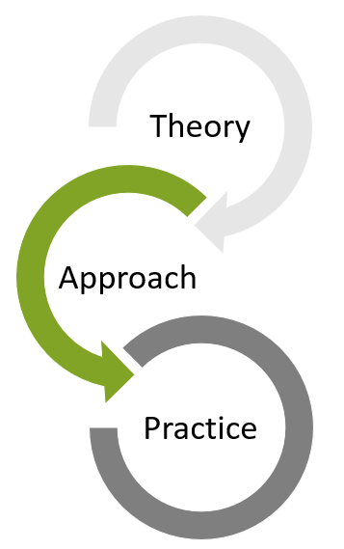
There are different ways of categorizing theories that inform advising. The Student Development Transit System Map is a fun way of looking at many of these theories. It can provide a springboard for additional studies. In THIS module we will talk about Cognitive Theories, Psychosocial Theories, and Person-Environment Fit Theories.
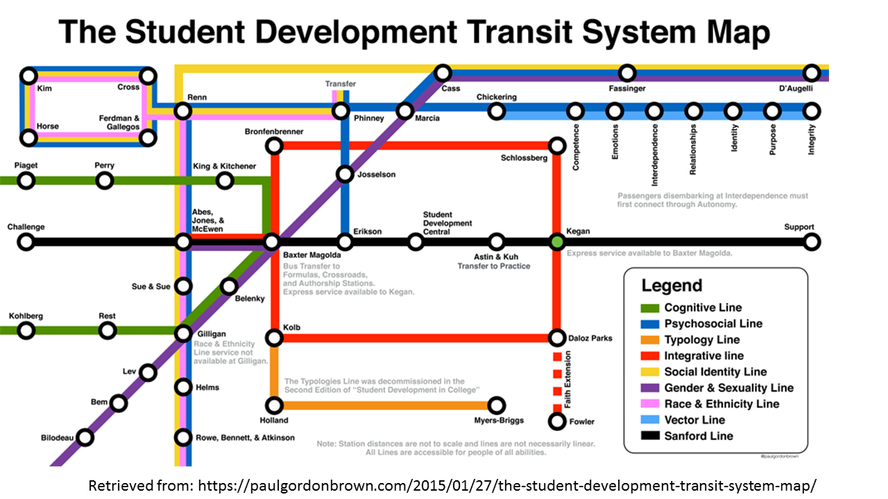

[Slide] Cognitive Theories
Cognitive theories explain how thinking, perception, and understanding develop. These theories describe sequential stages that describe cognitive structures. These stages organize how events are experienced by the individual. We will talk in more detail about experiential learning, social learning theory, and growth mindset later. But here you can see Perry’s Cognitive Theory. This theory shows us how people move from more simplistic ways of thinking (dualism) where information is either right or wrong to more complex ways of thinking which involve development and commitment to their own values. You can use these theories to help you understand how student make meaning in their lives and why student may be experiencing confusion.
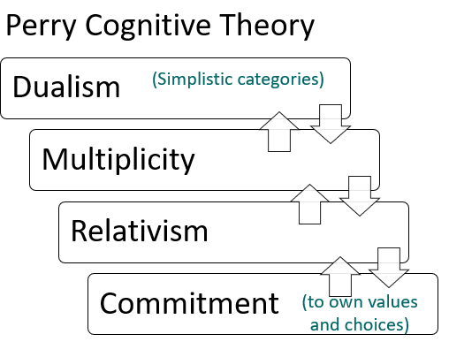

[Slide] Psychosocial Theories
Psychosocial Theories describe human development as a series of stages each presenting a task to complete or conflict to resolve before moving onto the next. This development occurs in the interactions of the individual with society. We will talk more about Baxter Magolda’s Self-Authorship theory, but here you can see Chickering’s Seven Vectors which build on Erikson’s Theory of Psychosocial Development. Chickering’s theory specifically addresses 18-25 year-olds and lays out seven developmental tasks (or vectors) that an individual typically faces during this time. According to Chickering, development occurs through cycles of differentiation and integration. In other words, a person must question their prior knowledge for development to happen. Advisor educators can help by creating situations that present conflicting information and by viewing expressions of confusion or disagreement as an opportunity to teach.

Psychosocial theory helps advisors understand common life struggles which can give you some insight into students’ comments and questions. It should be noted that many of these theories were developed while studying only white males. Additional work has been done that addresses development of other groups. Look in references and resources for additional information.
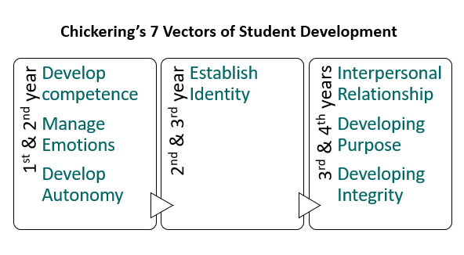
[Slide] Person-Environment Ineractions
Person-Environment Interaction theories explain a person’s behavior as a function of their interaction with their environment. Outcomes are generally better when the attributes of the person and of the environment are closely matched. We will talk in more detail about Holland and Schlossberg’s theories later, but here you can see Sanford’s Theory of Challenge and Support. This theory shows us that in order to develop, people need a balance of challenge and support. Too much support and a person will not learn. Too much challenge and the person may become too frustrated and quit. According to these theories, feelings can often be traced to the degree of fit between student and their environment. You can use these theories to help you understand a student’s reaction to the learning environment and give you cues about the referrals that might help increase a student’s sense of environmental fit.
- 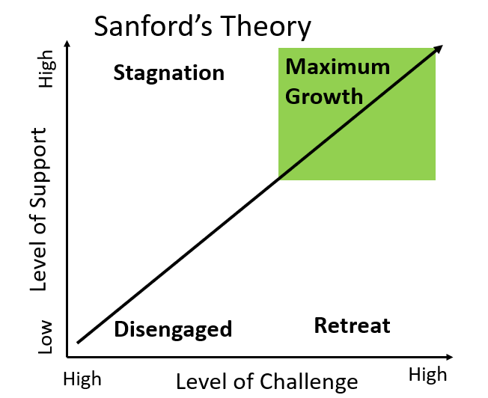

2. Student Engagement

- Reasons to Engage [Video]

We often talk about the benefit of improved learning when we talk about engaging students. Of course, this is a hugely important reason, but after an extensive review of engagement literature Trowler (2010) identified several additional reasons that engaging students is important. One reason is
• to improve retention – retention means a lot for the individual student, but institutions also face financial penalties when a student is not retained. Often dissatisfied students fail to take advantage of opportunities that might help them such as course advice or peer support. It can be just as important to keep an eye on who is NOT participating as who IS participating. Another reason is
• for equality/social justice reasons– with a greater emphasis on access, the student body has much greater diversity today in terms of ethnicity, socioeconomic status, disability and age. For these students, engaging and purposeful activities can be especially important to helping them persist. Also,
• for curriculum relevance – when students are more involved and active, they perceive the curriculum as more relevant. Another reason is
• for institutional benefit – engagement provides a way to increase the quality of the institution as measured by NSSE benchmarks, and since engaged students tend to be more engaged alumni, the institution can also benefit financially.
• as marketing – is another reason to engage students. if engagement is an indicator of quality, then an institution can use their success at engaging student as a marketing device.
• Lastly Trowler identifies economics – with concerns over the value for higher education, there is a need to better understand the cost/benefit relationship of highly engaging activities.
But what exactly is engagement? Groccia offers a model of student engagement that shows that student must interact with the learning process cognitively, affectively, and behaviorally. To engage, the student must be interested, make some effort, and mentally process the experience. Educators and the institution need to engage students at all three levels – doing, feeling, and thinking. Studies have shown that campuses with the most engaged students have created opportunities for engagement in all six dimensions which include engagement with faculty and staff, with other students, and the community in teaching, in learning and in research.
As we learned in Module 2, academic advisors play an important part in promoting positive student outcomes. An important way to promote student success is through helping them to become engaged on campus. This model can help us to consider the ways that we might involve students. You can explore ideas to engage students in all six dimensions on the next slide.

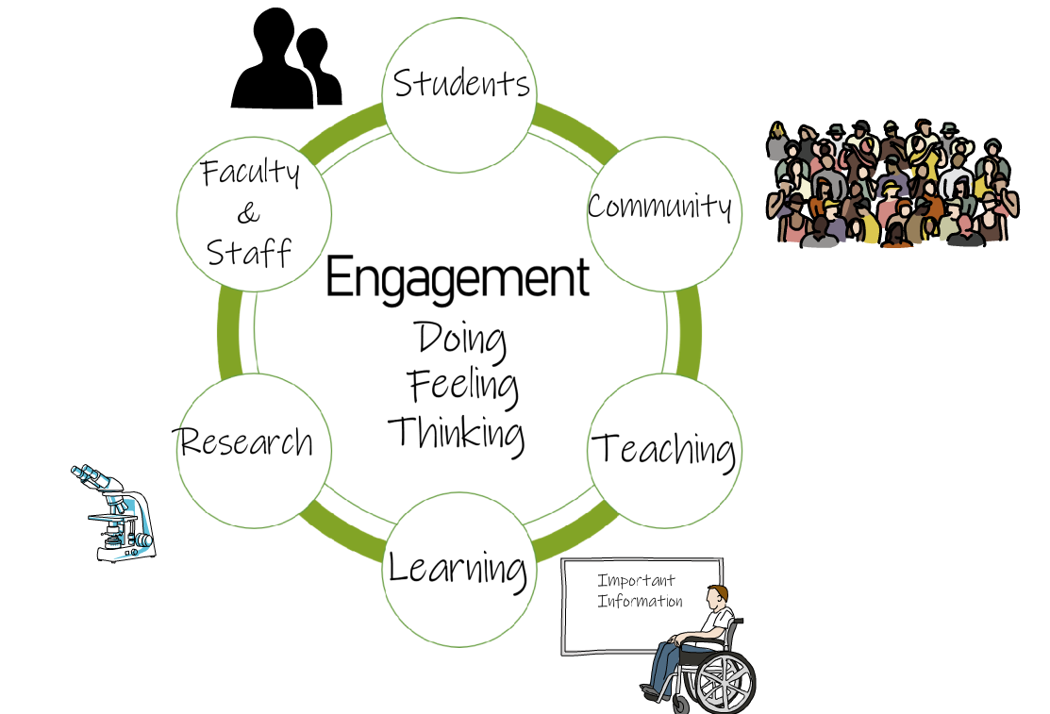

[Slide] Ways to Engage Students

Flip the cards below to get some ideas for how to help students become engaged in the six dimensions of Groccia’s model of student engagement.
Faculty and staff – research experiences, tutorials, conferences, academic clubs
Other students – residence hall communities, study groups, peer tutors, clubs
Community –service and outreach activities that enhance class work
Teaching – teaching assistants, peer mentors, and tutors, group projects that encourage students teaching students
Learning –cooperative learning, problem-based learning, critical thinking activities, pair and share
Research – students can be involved in undergraduate research which has been shown to have numerous positive impacts including increased interest in steam careers, increased persistence, and gains in skills such as speaking effectively and acquiring information.

[Slide] The National Survey of Student Engagement
The National Survey of Student Engagement (NSSE) is an annual survey of first year and senior students at hundreds of universities. NSSE looks at two critical features of collegiate quality: 1) the amount of time and effort students put into their studies and other educationally purposeful activities, and 2) how the institution deploys its resources and organizes the curriculum and other learning opportunities to get students to participate in activities that decades of research studies have shown are linked to student learning.
Click the link to find out more about NSSE indicators.
http://nsse.indiana.edu/pdf/EIs_and_HIPs_2015.pdf
[Slide] Ten Principles for Enhancing Student Engagement
The NSSE Engagement Indicators, provide ideas about how you can build an engaging environment. You can also use the indicators in your work with individual students to help figure out where a student may have become disconnected and then help them to find ways to reconnect. Here are Ten Working Principles for Enhancing Student Engagement (Krause, 2005):
- Create and maintain a stimulating intellectual environment:
- Give students good reasons to be part of the learning community.
- Provide a coherent and current course structure.
- Stimulate discussion and debate, exploration and discovery.

- Value academic work and high standards:
- Actively encourage commitment to study by attaching importance to studying and spending time on academic work.
- This may need to be modelled for students in first year so that they learn how to balance the different dimensions of their lives.

- Monitor and respond to demographic subgroup differences and their impact on engagement:
- Make it a priority to get to know your students, their needs, aspirations and motivations.
- Monitor the subgroup differences and develop targeted strategies for engaging students according to their needs and background experiences.
- This provides a powerful platform for supporting and teaching students in a responsive way so as to maximize the possibilities for engagement.

- Ensure expectations are explicit and responsive:
- Communicate expectations clearly and consistently across the institution and within faculties and departments.
- Reiterate expectations at appropriate times through the semester and in different settings – before semester begins, and before and during peak stress times in the semester.
- Include students in expectation-building. Listen to their expectations. Be responsive where appropriate.

- Foster social connections:
    - In small groups: Opportunities for active and collaborative learning are particularly important including problem-solving activities and discussion of class materials.
    - In large lectures: Foster interaction through question answer sessions and interactive activities that help to break down large group anonymity.
    - Online: Provide for online discussion, collaboration and interaction.
    - Create opportunities for civic engagement with communities beyond the campus.

- Acknowledge the challenges:
    - Let students know that you/your department/unit/institution understand and are aware of some of the pressures they face.
    - Acknowledge that a large proportion of students will be juggling work and study commitments throughout the semester. This may be done in reading guides, lectures or tutorials.
    - Be explicit and proactive in dealing with issues and challenges that potentially jeopardise student engagement.

- Provide targeted self-management strategies:
    - Seek to develop self-regulated learners who drive their own engagement behaviors.
    - Discuss strategies for time management and maintaining motivation, particularly during stressful times of semester.
    - Identify the various sources of help early in the semester and at key moments through semester so that students are prepared ahead of time. They need to know that they are not alone and where to go for help.

- Use assessment to shape the student experience and encourage engagement:
- Provide feedback and continuous assessment tasks early and often.
- Use assessment in creative ways to bring peers together both in and out of the classroom.
- Engage students in self-assessment and peer assessment so that the focus is increasingly on their responsibility for becoming and remaining engaged in the learning process.

- Manage online learning experiences with care:
- Students indicate that even when all lecture notes are on the web, they will attend lectures if the lecture is interesting and presented well.
- When lecture material is presented online, develop strategies for encouraging student involvement during lectures. For example, integrate activities into the lecture timeslot.
- Capitalize on the community-building capacities of online discussion to connect students to each other and to the learning community

- Recognize the complex nature of engagement in your policy and practice:
- binds students to each other, to meaningful learning activities, and to the institution.
- creates conflict and turmoil for some students.
- may be one of many engagements in their daily calendar of activities.
- brings with it reciprocal rights and responsibilities.
- should create a mutually beneficial relationship that continues well beyond graduation.
- changes over time – monitor the changes especially at transitions.

- Transition

[Slide] Schlossberg’s Theory of Transition
The transition to college can be challenging. Schlossberg offers a way of describing transitions that we can use when helping students.
Not all transitions are the same. Some are. . .
- Anticipated Transitions – these are events that might be expected such as starting college, moving into a career, or starting a family.
- Unanticipated Transitions – are events that were not expected to happen such as loss of a job, relationship, or loved one.
- Nonevents – occur when an anticipated transition does NOT happen such as not get married or having children.
It is also helpful to look at the Degree of Change that the transition causes. How different are roles, relationships, routines, and assumptions?
A student moving across country to attend college on their own is likely experiencing large changes in all of these areas. Moving from home has shifted roles, relationship with family and friends left behind have changed significantly, and routines are completely new. In addition, a new environment may challenge a students’ assumptions about what their college experience was “supposed” to be about. On the other hand, most commuter students would experience a lesser degree of change because they have kept more aspects of their situation the same.
It is also helpful to consider where one is at in the transition process. Is the person just considering a change? Are they at the beginning of making a change? Or has it been some time after the change? People’s perspective about change and transition does not remain static.
[Slide] How can advisors help?
Four factors that influence a person’s ability to cope with a transition are 1) the characteristics of the situation such as the trigger or duration, 2) aspects of the self, such as health and culture, 3) available supports, and 4) strategies to manage the transition.
Purposefully looking at the details of a transition helps the advisor and student identify areas where they can make adjustments in order to cope.
Let’s look at an example using these four factors. A first-year student tells you they are considering dropping out. By talking through details about the situation, you learn that the student leaves campus as soon as possible to work in the family business. In terms of self, you learn that the student feels responsible to help their family but that the family is not putting pressure on the student to come home. Because the student is leaving as soon as possible, they are not making connections on campus so do not have much support. So you and the student brainstorm strategies to improve their circumstance. You connect the student with some campus organizations and the student decides to adjust their work schedule so they can attend a couple of group meetings.
- Situation – Look at the trigger, timing, role change, duration, and who is responsible for the transition.
- Self – What inner strength does the person bring that can help them cope? This can be related to age, gender, health, culture, or religious beliefs.
- Support – Identify available supports: family, friends, institution, community.
- Strategies – to cope with a transition, a person may be able to modify some aspects of the situation, control or modify the meaning they are giving to the transition, and take steps to manage stress.
As an advisor, we may have some limited ability to adjust a situation for a transitioning student (for example, by helping a student drop a course if needed). And we may be able to help students understand factors related to the Self that might be impacting their experience of transition into college, but the main ways we can help is through assisting students to build support and develop strategies for coping with the transition. You can also make referrals to other services such as counseling when a students’ issues are outside the scope of academic advising.
Explore the four factors a little more by flipping the cards.

[Slide] Self-Authorship (Baxter Magolda)
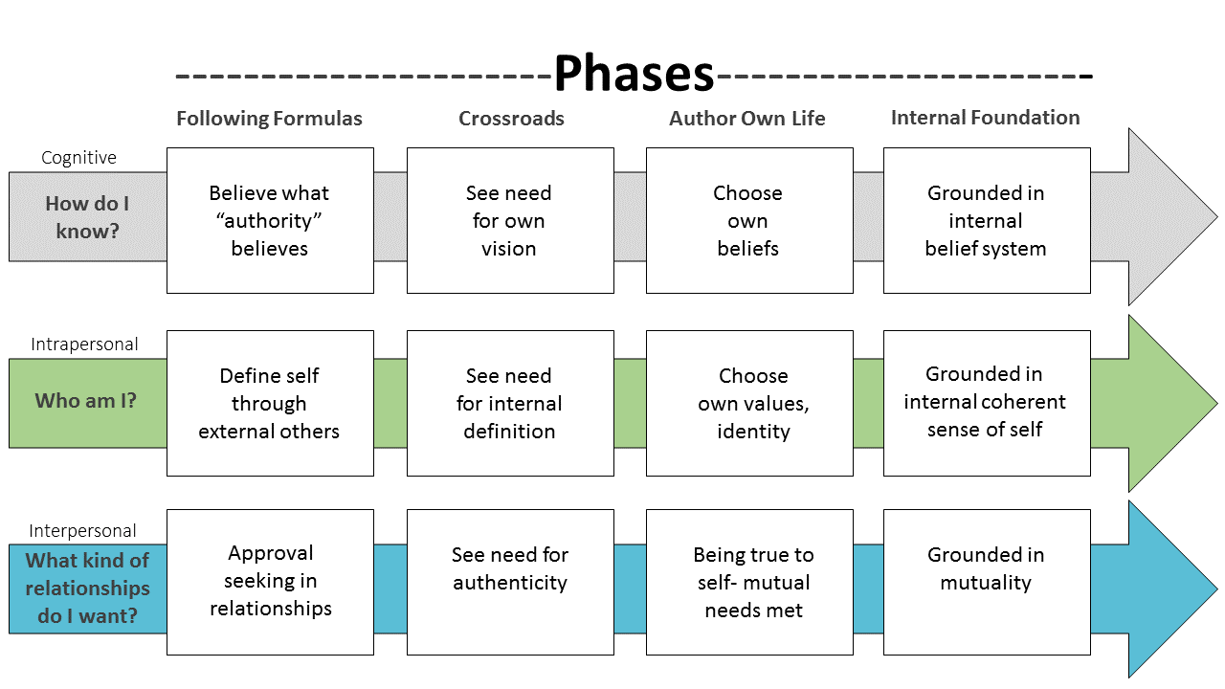

There are other ways of thinking about transitions that your students may be experiencing.
Baxter Magolda (2001) defined self-authorship as "the internal capacity to define one's beliefs, identity and social relations" (p.269). Guided by three foundational questions, a person moves through four phases of self-authorship. These three questions are: “How do I know?”, “Who am I?”, and “What kind of relationships do I want?”
People start by answering these questions according to what their parents and other authority figures have told them. At some point, the individual comes to a crossroads. This is typically because either the strategies they have followed have not worked or because the situations have worked, but the results were not fulfilling. The next phase is self-authorship in which the individual chooses their own beliefs and identities, and begins to establish relationships built on mutual needs. It is helpful to know many college students are in the crossroads phase and advisors can help to support them as they move toward self-authorship.

[Slide] Learning Partnership
Self-authorship emerges in environments that challenge dependence on authority and meaning-making processes. According to Baxter Magolda, such environments are based on three principles. The first is to validate the student as knower- in other words make sure students know their thoughts and opinions are valuable.
Second, situate learning in students’ own experience- acknowledge the personal experiences that students bring to the classroom and promote discussion about differences.
And third, define learning as jointly constructed. Frame teaching and learning as something that is done together rather than as information “received”.
Baxter Magolda calls this the Learning Partnership Model. As an advisor, you can help to create this type of environment. Over the next few slides you will learn about ways that you can incorporate these three principles into your practice.

- Validating the Student as Knower
- Ensure students know that their thoughts and opinions are valuable
- Encourage active sharing of ideas and viewpoints
- Provide opportunities for students to act as an authority/leader (helps them learn how to share power and how to communicate with others especially through challenging situations)
- Demonstrate that you are also able to share power
- Be more human, approachable, and concerned—students more likely to see knowledge construction as reachable
[Slide]
- Situating Learning in Students’ Own Experience
- Acknowledge personal experiences that students bring to the classroom
- Promote free and civil dialogue about differences
- Avoid marginalizing students (by using unfamiliar topics or always using the same pronoun)
- Make sure that students from marginalized groups are included in leadership positions
- Use analogies, drawing from student experiences, sharing stories
- Explain the relevance of material to students' daily lives
- Provide opportunities for self-reflection
- Develop assignments that draw from and relate to student experiences
- Offer guidelines to students, rather than requirements

[Slide]
- Defining Learning as Jointly Constructed Meaning
- Frame teaching and learning as something you do together
- Promote multiple viewpoints to encourage a collaborative culture
- Allow students to see your thinking, judgment, and decision-making

[Slide] Transfer Students
In addition to the transition difficulties that can occur when a student begins college for the first time, students who are moving between institutions can also experience challenges. This period in-between moments of stability can cause confusion and disorientation known as transfer shock. Early definitions of transfer shock focused on a GPA dip experienced in the first semester, but newer research has expanded the definition to include academic and social factors that contribute to increased attrition and lack of persistence.
There are several things academic advisors can do to help students transferring from other institutions (Ivans et al, 2016).
- First, advisors can help students BEFORE transfer by developing relationships with sending institutions. Sharing program information and requirements with sending advisors will help students have a good understanding of what to expect before they arrive.
- Once they are here, it’s important to let students know that transfer shock is a common reaction and CAN be worked through. Make sure to connect students with any formal programming available for transfer students.
- Students who are engaged with others and active on campus tend to be more satisfied and more persistent. So do what you can to connect students to opportunities for socialization with other students and faculty.
- And lastly, provide opportunities for mentoring. This can be formal faculty-based mentor program or peer mentoring is another possibility.
Campus support has been shown to have a positive long term effect on students’ adjustment, so your efforts can make a real difference to a transfer student.

- Activity
Identify special programs and resources available for transfer students
- at your institution
- for your program
Review linked resources for additional information.
https://muse.jhu.edu/article/539121
https://www.nacada.ksu.edu/Resources/Clearinghouse/View-Articles/Resources-for-advising-transfer-students.aspx
https://www.nacada.ksu.edu/Resources/Clearinghouse/View-Articles/Advising-Transfer-Students.aspx

3. Teaching and Learning

- [VIDEO] – Advising as Teaching
As we have learned, there are different ways of characterizing the role of academic advisor. One of these is the role of academic advising as teaching. According to Lowenstein and Stockton, the essence of academic advising is helping students to make connections between their learning experiences. Making these connections builds a strong foundation for lifelong learning. These authors point out that as a professional advisor, it is important that you have the opportunity to hear the decisions and conversations that faculty are having regarding courses (such as prerequisites) so that you can help students make these connections for themselves.
If advising is teaching, then we should be able to identify an advising curriculum. Hemwall & Trachte provide principles to help guide the teaching we do as advisors. The first three focus on what students should learn through advising and the last seven address how learning takes place within the advising relationship.
Academic Advising should facilitate student learning about the mission of the university. You will remember we talked about this in module 2. This can help students to understand how their personal goals and the goals of the institution align.
In addition to teaching about the mission itself, you also teach students how to achieve the goals embedded in the mission.
Advisors also help student learn and improve their thinking skills. We will discuss one way of doing this a little later when we talk about Carol Dweck’s theory - Growth Mindset.
Academic advisors should view students as actively constructing their OWN understanding of the mission of the institution, including concepts like becoming responsible citizens and critical thinkers.
Advisors should adjust their approach and recommendations to incorporate knowledge about how the individual student learns.
They should consider how the social context affects the learner’s understanding and recognize that possibilities for learning are influenced by the advisee’s perceptions and background knowledge.
Advising should be a dialogue in which the learner has the opportunity to express, justify, and discuss individual goals and ideas with the academic advisor being a guide.
Advisors should help students to understand how their thinking can benefit by recognizing errors and contradictory information.
Next, we will look at a developmental perspective of the teaching that takes place in the advising relationship.

[slide] Cultivating Ways of Thinking
McGill provides a vision of developmental teaching that shares a number of elements with Hemwall and Trachte’s description of how learning takes place in the advising relationship. For example, the role of a student’s prior experiences in shaping their understanding and the learning benefits of errors and contradictions are both addressed
McGill tells us that advising is fundamentally attached to the teaching mission of the institution and that the teaching that takes place in advising should be learning-centered and adjust to student differences. Advising educators assess student’s knowledge, cognition, motivation, and strengths. They should respect students’ thinking and prior experience and use it as a starting point for building knowledge. Developmental teaching includes teaching students how to think differently and how to make good decisions. This concept map provides some details regarding McGill’s eight aspects of developmental advising.
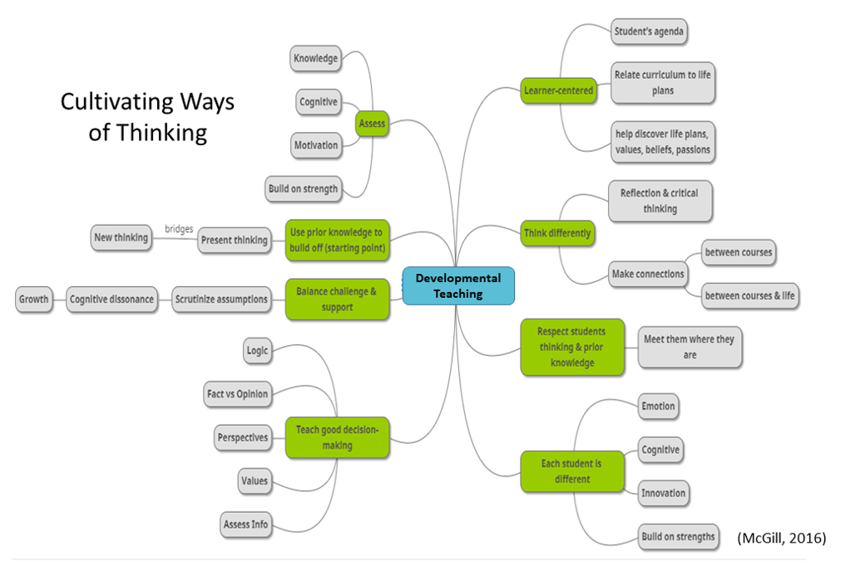

- Kolb Experiential Learning Theory
As advisors, you can use knowledge of how people learn to increase students’ understanding about their own learning. The Experiential Learning Cycle, developed by David Kolb, is depicted as a circle or spiral in which learning can begin at any point along concrete experience, observation and reflection, forming abstract concepts, and testing new situations.
Learning involves understanding the effects of actions and determining the general principle under which a particular instance falls.
Concrete experiences happen.
A person reflects upon what has happened and extracts new ideas from what has been observed.
The person then applies this concept to new situations to see how it fits.
Learning can begin at any point in the cycle and then will progress through to the next phase, however, the most effective learning involves all four phases. Which is something to consider when planning learning experiences for your students. The most successful educators address all four learning cycle modes – experiencing, reflecting, thinking and acting. Additionally, Kolb and Kolb caution that often experiences and academic coursework are separated when being offered TOGETHER really strengthens both.
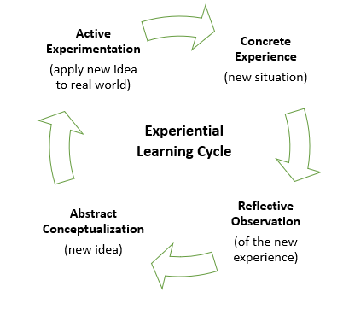

- Growth Mindset Slide
Carol Dweck’s research identified two different ways that people view intelligence and learning - either with a fixed mindset or a growth mindset.

Those with a fixed mindset believe that intelligence is something that you are born with and that you ALWAYS have the same amount.

People with this mindset value looking smart, BUT because they believe that intelligence is SET they will avoid opportunities that might help them for fear of exposing deficiencies.

People with this mindset feel DUMB if they have to work very hard and tend to get defensive when they face setbacks because in their mind, these difficulties call into question their intelligence.

People with a GROWTH mindset, on the other hand, believe that intelligence can DEVELOP.

They love challenges because they see them as an opportunity to learn and grow.

People with a growth mindset value effort and will work very hard even in when they face setback. They simply use these as opportunities to try new strategies. People with a growth mindset TEND to reach higher levels of achievement than those with a fixed mindset.

As advisors, there are a few things that we can do to help students develop a growth mindset.

First, we need to be careful with our language. Dr. Dweck has found that praising intelligence can actually have the opposite effect of what we desire.

Instead emphasize the value of a CHALLENGE and praise the process and effort a student is making.

Sometimes students can lose track of the small changes that they have made, so point out progress when you can.

You can also share information about growth mindset with students so they begin learning how to think about their own thinking.

Video link: https://www.youtube.com/watch?v=J-swZaKN2Ic

- Career Development

- [slide] Introduction
The idea that academic advising should include career exploration has been around for a long time. O’Banion, in 1972, included vocational goals as one of the five steps of the advising process which include exploration of life and vocational goals, selection of academic program and selection and scheduling of courses.
And this makes sense, right?
While preparation for a career is not the only reason to attend college, it certainly is priority for most college students. And in order to know which program will best prepare them, a student has to form vocational goals informed by their larger life goals.
So even if you have a dedicated career center on your campus, you will still be working with students who are in the process of choosing a vocational path. Understanding theories about career choice can help you to better support students on this journey. If your institution has a career center, it is a good idea to get to know their staff and services. Talk to them about how you can work together and about when it is best to refer a student.
You will find a link to your career center at the end of this section.

- [Slide] Super’s Developmental Self-Concept Theory
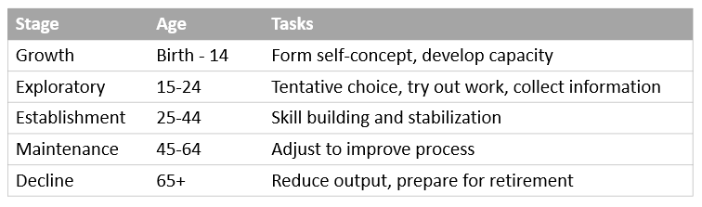

Super takes a lifespan view of career development. According to THIS theory, vocational choice is the PROCESS of developing and implementing a self-concept rather than something that happens at one point in time.
As the self-concept becomes more realistic and stable, so does vocational choice and behavior. People choose occupations that permit them to express their self-concepts. Work satisfaction is related to the degree to which a person has been able to implement their self-concepts.
There are developmental tasks associated with each stage, however let’s focus on the ones that are part of the exploratory stage which many college students will be experiencing.
During this stage individuals are forming a general vocational goal then moving from a tentative to a specific goal, and next taking the steps necessary to meet the goal by completing training and entering employment.
Advisors can use this theory to
- Identify a student’s stage and to help them set related goals.
- Advisors can also help student clarify their self-concept and make connections to occupational information.
- Students also benefit from being exposed to a wide range of careers and specific information about lifestyle implications.
- And lastly, advisors can encourage students to gain work experiences through volunteering and internships in order to “try on” roles.

- Social Cognitive Career Theory
[Slide] Introduction
Social Cognitive Career Theory (SCCT) is a theory developed by Robert W. Lent, Steven D. Brown, and Gail Hackett in 1994 based on Albert Bandura’s social cognitive theory. SCCT seeks to explain three aspects of career and academic development including how interests develop, how choices are made, and how academic and career success is obtained.
Self-efficacy refers to an individual's personal beliefs about their capabilities to perform particular behaviors or courses of action.
Outcome expectations refer to beliefs about the consequences or outcomes of performing particular behaviors.
Personal goals may be defined as one's intentions to engage in a particular activity or to attain a certain level of performance.
People are likely to form lasting interest in an activity when they view themselves as competent at performing it and when they expect the activity to produce outcomes that they value.
On the other hand, interests are UNLIKELY to develop in activities for which people doubt their competence and expect negative outcomes. Interests can also be constrained by lack of resources or discouragement from others. When faced with obstacles, people turn to more pragmatic concerns about what work is available.
[Slide] Ability influences persistence
The SCCT model also describes performance. Ability (as reflected in past achievement and aptitudes) is assumed to affect performance in two ways.
First, ability influences performance and persistence directly- students with higher aptitude in a particular subject tend to do better and persist longer in that subject than do students with lesser aptitude.
Ability also influences performance and persistence indirectly through the intervening paths of self-efficacy and outcome expectations. Controlling for level of ability, students and workers with higher self-efficacy and more positive outcome EXPECTATIONS will be more likely to:
- establish higher performance goals for themselves (i.e., aim for more challenging attainments)
- to organize their skills more effectively,
- to persist longer in the face of setbacks. As a result, they may achieve higher levels of success than those with lower self-efficacy and less positive outcome expectations.
SCCT can help us to understand the paths by which students make choices and perform academically and in their careers.

- Holland Theory of Vocational Types
Holland proposed that occupation choice is an expression of personality. He describes six different personality and work environment types. According to Holland, people tend to have three of the six types that are more dominant. Holland Codes are expressed from most to least dominant- for example ASE indicates that Artistic is most dominant, then Social, then Enterprising.

6 Holland Types
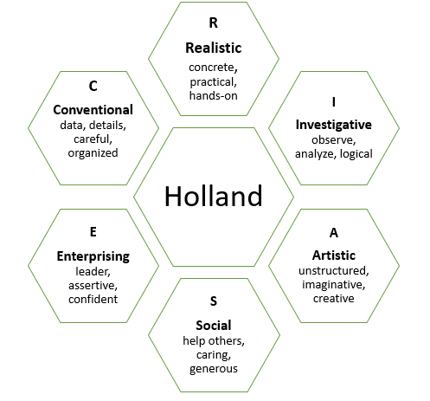
Members of particular occupations share characteristics and tend to respond to situations and problems similarly. People are most successful and satisfied when their job environment closely matches their personality which Holland refers to as congruence or incongruence.
Types nearer each other on the hexagon are more like each other. Differentiation refers to the spread of a person’s three dominant types. If traits cluster toward one side of the hexagon, they are considered differentiated. Undifferentiated means that dominant types are NOT near each other. This can create a tension when it comes to finding a good job match. One strategy might be to focus on the most dominant type and then help the student think of other ways to satisfy some of their other interests.
The types provide a fairly easy way to start thinking about different work environments and have been well researched and appear to be stable over time and across gender and racial lines.
Holland code descriptions https://career.missouri.edu/career-interest-game/
- Activity
Review the career center resources available at your university. Try to make time for a visit.
UMKC:
https://career.umkc.edu/
MU:
https://career.missouri.edu/
S&T:
https://career.mst.edu/
UMSL:
https://www.umsl.edu/depts/career/

- References/Resources

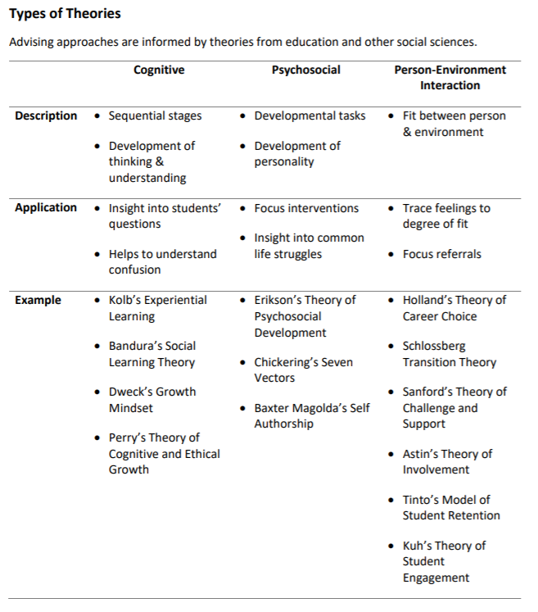
References
Anderson, W., Motto, J. S., & Bourdeaux, R. (2014). Getting what they want: Aligning student expectations of advising with perceived advisor behaviors. Mid-Western Educational Researcher, 26(1), 27051.
Baxter Magolda, M. (2001). Making their own way: Narratives for transforming higher education to promote self-development. Sterling, VA: Stylus
Baxter Magolda, M.B. (2014). Self-authorship. New Directions for Higher Education, 166 (Summer) (2014), pp. 25-33.
Bullock-Yowell, E., McConnell, A.E. & Schedin, E.A. (2014) Decided and Undecided Students: Career Self-efficacy, Negative Thinking, and Decision-Making Difficulties. NACADA Journal: 2014, Vol. 34, No. 1, pp. 22-34. https://doi.org/10.12930/NACADA-13-016
Creamer, D. G., & Creamer, E. G. (1994). Practicing developmental advising: Theoretical contexts and functional applications. NACADA Journal, 14(2), 17-24. http://dx.doi.org/10.12930/0271-9517-14.2.17
Demetriou, C. (2005). Potential applications of social norms theory to academic advising. NACADA Journal, 25(2), 49-56. http://dx.doi.org/10.12930/0271-9517-25.2.49
Dweck, C. (2010). Even geniuses work hard. Educational Leadership, 68(1), 16-20 retrieved from http://www.ascd.org/publications/educational-leadership/sept10/vol68/num01/Even-Geniuses-Work-Hard.aspx
Grites, T. J. & Stockton, R., (2013). Developmental academic advising: A 40-year context. NACADA Journal, 33(1), 5-15. http://dx.doi.org/10.12930/NACADA-13-123
Groccia, J. (2018). What is Student Engagement? New Directions for Teaching & Learning, (2018) 154, p11-20.
Hall, M. (2013). Perry’s scheme – Understanding the intellectual development of college-age students. Frm the Innovative Instructor Blog from Johns Hopkins University. Retrieved from https://ii.library.jhu.edu/2013/12/13/perrys-scheme-understanding-the-intellectual-development-of-college-age-students/
Hemwall, M. K., & Trachte, K. C. (2005). Academic Advising as Learning: 10 Organizing Principles. NACADA Journal, 25(2), 74-83. http://dx.doi.org/10.12930/0271-9517-25.2.74
Himes, H., & Schulenberg, J. (2013, September). Theoretical reflections: Theory and philosophy should always inform practice. Academic Advising Today, 36(3). Retrieved from https://www.nacada.ksu.edu/Resources/Academic-Advising-Today/View-Articles/Theoretical-Reflections-Theory-and-Philosophy-Should-Always-Inform-Practice.aspx
Ivins, T., Copenhaver, K., & Koclanes, A. (2016). Adult transitional theory and transfer shock in higher education: practices from the literature. References Service Review, 45(2), 244-257.
Jaeger, A. J., Dunstan, S., Thornton,C., Rockenback, A. B., Gayles, J. G., & Haley, K. J., (2013). Put Theory into Practice. About Campus, 17(6), 11-15.
Kolb, A. Y., & Kolb, D. A. (2017). Experiential learning theory as a guide for experiential educators in higher education. Journal for Engaged Educators, 1(1), 7-44.
Krause, K.E. (2005) Understanding and promoting student engagement in university learning communities. Keynote address presentation, James Cook University Symposium. Available online at: http://www.liberty.edu/media/3425/teaching_resources/Stud_eng.pdf
Kuh, G.D. (2009). What Student Affairs Professionals Need to Know about Student Engagement. Journal of College Student Development. 50 (6), pp. 683–706.
Lent, R.W. & Hackett, G. & Brown, S.D. (2008). In the Encyclopedia of Counseling: Social Cognitive Career Theory. Editor Frederick T. L. Leong. SAGE Publications: Thousand Oaks. DOI: http://dx.doi.org/10.4135/9781412963978.n585
Levin, J., & Brazil, T. A. (2008). Decision-making theory: Implications for academic advising. The Mentor. Retrieved from https://dus.psu.edu/mentor/old/articles/080604jl.htm
Lowenstein, M. & Stockton, R. (2005). If advising is teaching, what do advisors teach? NACADA Journal, 25(2), 65-73. Retrieved from https://pdfs.semanticscholar.org/629f/e38ec677d236dbc7fb2b05d305fbc9eb2758.pdf
Lowenstein, M. (2012, June). Theoretical reflections: Why a theory of advising? Academic Advising Today, 35(2) retrieved from https://www.nacada.ksu.edu/Resources/Academic-Advising-Today/View-Articles/Theoretical-Reflections-Why-a-Theory-of-Advising.aspx
McCalla-Wriggins, B. (2009). Integrating Career and Academic Advising: Mastering the Challenge. Retrieved from NACADA Clearinghouse of Academic Advising Resources website: http://www.nacada.ksu.edu/Resources/Clearinghouse/View-Articles/Integrating-career-and-academic-advising.aspx
McGill, C. M. (2016). “Cultivating ways of thinking”: The developmental teaching perspective in academic advising. New Horizons in Adult Education & Human Resource Development, 28(1), 50-54. http://dx.doi.org/10.1002/nha3.20131
National Survey of Student Engagement (NSSE) retrieved from http://nsse.indiana.edu/html/about.cfm
Neal, R. (2015, October). Using Chickering to Get Ahead. NACADA Annual Conference. Presentation conducted from Las Vegas. Retrieved from http://apps.nacada.ksu.edu/conferences/ProposalsPHP/uploads/handouts/2015/C329-H01.pdf
Schlossberg, N. K. (2011). The challenge of change: The transition model and its applications. Journal of Employment Counseling, 48(4), 159–162.
Sullivan-Vance, K., & Hones, S. A. (2009). Maslow, meaning and me: A theorist’s guide to advising administration. Retrieved from http://www.nacada.ksu.edu/Resources/Clearinghouse/View-Articles/Maslow-Meaning-and-Me.aspx
Teaching and Learning Center at the University of Tennessee. Self-Authorship Theory retrieved from https://uthsc.edu/tlc/self-authorship.php
Trowler, V. (2010). Student engagement literature review. The Higher Education Academy. Retrieved from http://www.lancaster.ac.uk/staff/trowler/StudentEngagementLiteratureReview.pdf
Williams, S. (2007). From theory to practice: The application of theories of development to academic Advising philosophy and practice. Retrieved from http://www.nacada.ksu.edu/Resources/Clearinghouse/View-Articles/Applying-Theory-to-Advising-Practice.aspx

