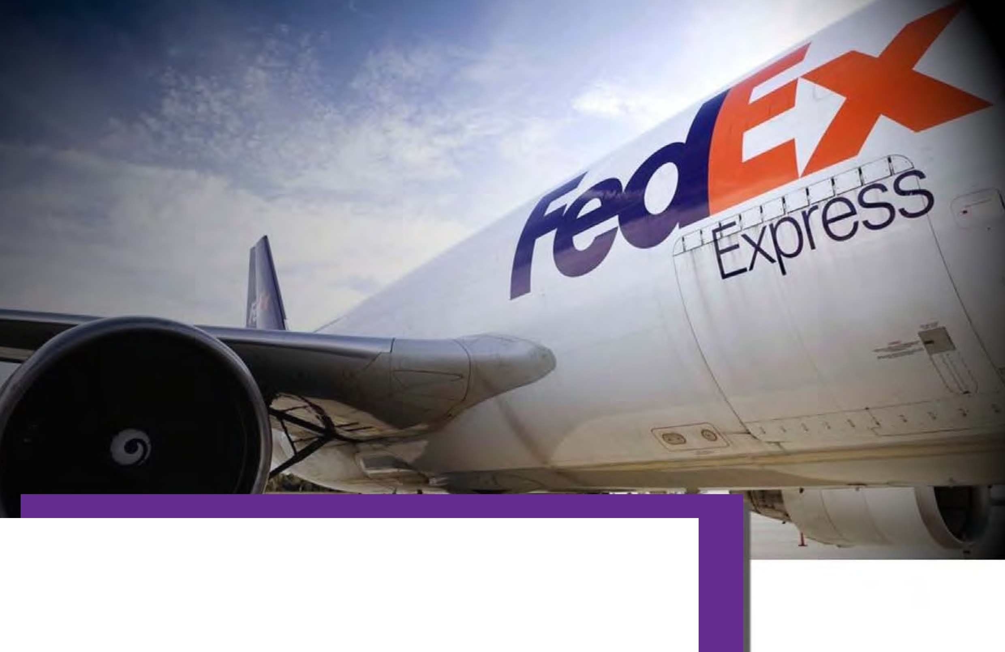

Better Rebates & Deeper Discounts with E&l's FedEx Contract

Using E&I's competitively awarded FedEx contract has its rewards!

In addition to unsurpassed savings and discounts, FedEx delivers a complete array of services and special features, as well as financial incentives for participants.

Drive down your shipping costs with these contract benefits:

- A Full 2% Rebate Back to your Institution Based on Total Usage Dollars
- NEW - Streamlined Rate Structure-Improving Overall Program Value
- No Pick Up Fees for Scheduled and On-Call Pick Ups
- NEW - SmartPost
- 2nd Day AM Express Service
- NEW - Ground Package Return Program
- Fuel surcharge cap at 12%
- Continued Bonus Weight Envelope Program
- On Time Money Back Guarantee

Getting Started is Easy!

£7 Coo eratlve
Services
IJ

So t1rcing . Str at l!8')', Sav/11,p.

Basics of E&I's FedEx agreement:

► Priority Overnight
► Standard Overnight
► Second Day Early AM
► Second Day
► Express Saver
► First Overnight
► Ground Shipping

Just complete the quick Account Sign Up form at www.eandi.org to either request a new FedEx Account number or convert your existing FedEx Account number.

The E&I FedEx contract continues to bring the maximum overall value to the educational marketplace. These enhancements provide even more reason to convert to this cost saving program.

To learn more about the E&I FedEx contract, please contact your E&I Member Relations Executive or visit our website at www.eandi.org.

Contract Details

Contract Effective Dates: Pricing/Discounts: Getting Started:

Place Orders With:

Terms: Invoicing:
Credit Card Accepted: Delivery Terms:

Claims:

Federal ID#: Invoicing by: Request Literature: Contract Number: RFP Number:

06/16/2008 - 06/30/2018

To view price lists for all services, please go to www.eandi.org.

To set up a new FedEx account, or convert an existing account to the E&I contract, please complete and submit the application located at www.eandi.org.

Once an account is established, package pick-ups can be arranged: Online atwww.fedex.com
FedEx Customer Service- 800.645.9424
  - Daily or weekly scheduled pick-ups
  - Drop boxes set up at institution site Net30days
FedEx

Visa, American Express and MasterCard As per the FedEx Service Guide.
Fees and Other Shipping Information
The Courier Pickup Charge has been waived for E&I members using this contract. (AKA Domestic On-Call, and International On-Call Pickup Fee).

Money Back Guarantee - Transportation charges refunded or credited, upon request, on shipments delivered after the delivery commitment time. Please refer to the FedEx Money-Back Guarantee Policy for details.

Claims shall be handled in conformity with the terms of the current FedEx Service Guide.

62-172743

FedEx Corporation marketinglit@eandi.org CNR-01193
682945

Product Overview: Express Package and Delivery Related Services

!ol Coo erative
O(i ServicesE
Sourcing. Strategy. Savings,

Note: When placing orders, please identify yourself as an E&I Member. All pricing and contract terms are strictly confidential and recipients are not authorized to disclose such informatoin to competing suppliers or use it in negotiations with existing or potential suppliers.

