Executive Summary of Program Assessment

The summary, including this page, should be no more than three pages.

Campus: University of Missouri-St. Louis

College/School: College of Arts & Sciences

Academic Unit: Department of Language and Cultural Studies

Date Submitted: 02/17/2020

Person Responsible for Success of Program:

Submitted by: UMSL

Degree Programs

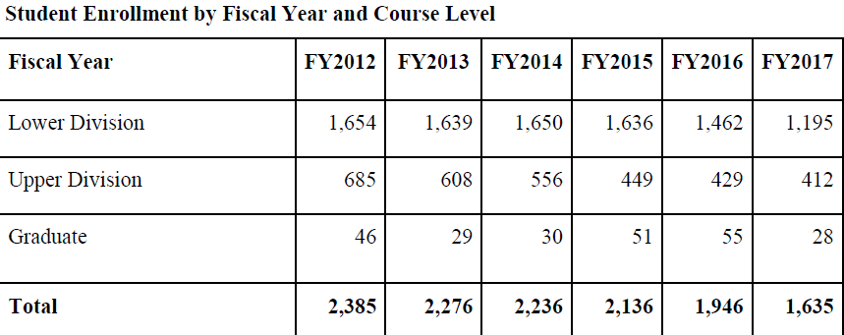

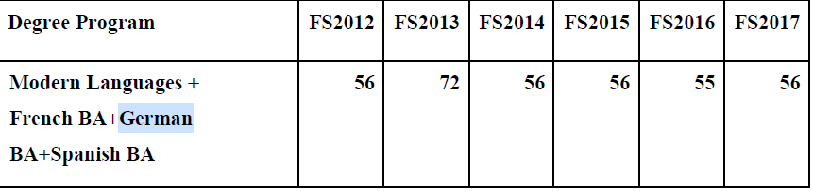

Changes since Last Review
Since the last review the Department of Language and Cultural Studies has separated from the departments of Anthropology and Sociology. The department no longer focuses on the traditional literature and grammar aspects of learning a language, but will focus more on studying real-world contexts and applications. The department has also created a Dual Language Professional Track due to an increasing demand for profession-oriented studies in language and cultures. To accommodate the new professional track the department has prioritized hiring candidates with the ability to deliver professions-based instruction. To improve the department’s Dual Language Track, they have brought on Susanne Evens, Founder and CEO of AAA Translation, who will serve as a consultant.

Strategies or Plans for Improving Program
The departments plans to hire new faculty that are highly versatile. By hiring versatile candidates it will allow the department to develop and teach courses that will focus on the department’s growth areas (ie. Translation and Interpretation, Spanish for the Science and Health Professions, as well as FL 1200 and 2100). The LCS department will also like to expand their amount of partnerships within the region so that we can grow our vibrant international community, keep culturally and linguistically trained talent in the region, and make St. Louis a competitive market for international businesses and organizations. The LCS department will also like to increase their funding for scholarships so that students can afford to study languages and immerse themselves in their cultures through travel and study abroad. They will also like to increase the amount of paid internships for students who cannot afford to partake in an unpaid internship. The department has reached out to Jennings School district to discuss a partnership that would provide college-level learning opportunities to low-income neighborhoods near UMSL. Also, the department would like to focus more on community building with its students.

Other Comments
Click here if you wish to include additional comments about program.

