
Browser recommendations: myVITA features work best in the latest versions of Mozilla Firefox, Google Chrome, and Safari browsers. Internet Explorer is not recommended because of issues with functionality and display. Please set your browser to accept pop-ups from the myVITA site to ensure an optimal experience.

Using myVITA Activities Reporting
The Activities Form is the area of myVITA where you keep track of professional activities, such as courses you’ve taught, scholarly contributions, committee service, mentoring, grants, professional development, and more.
Some information has been, and will be, pre-loaded for you from the university’s systems of record, including courses taught, grants and advising. In addition, if you used FAS (the Faculty Accomplishments System), these historical records were transferred into myVITA for your convenience. You may edit or delete these records at your discretion.
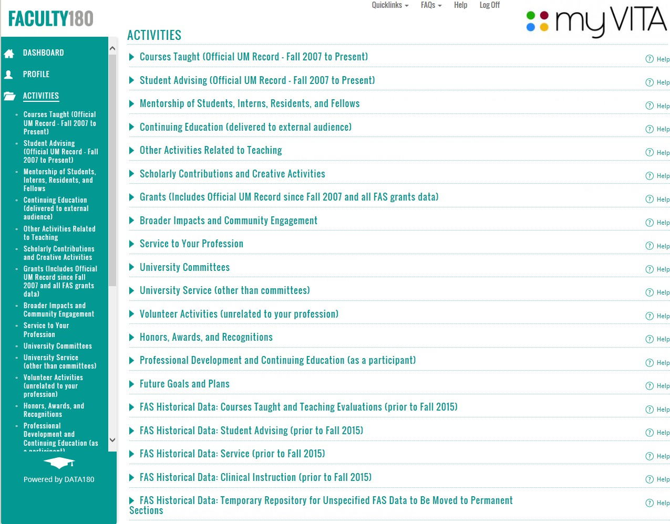
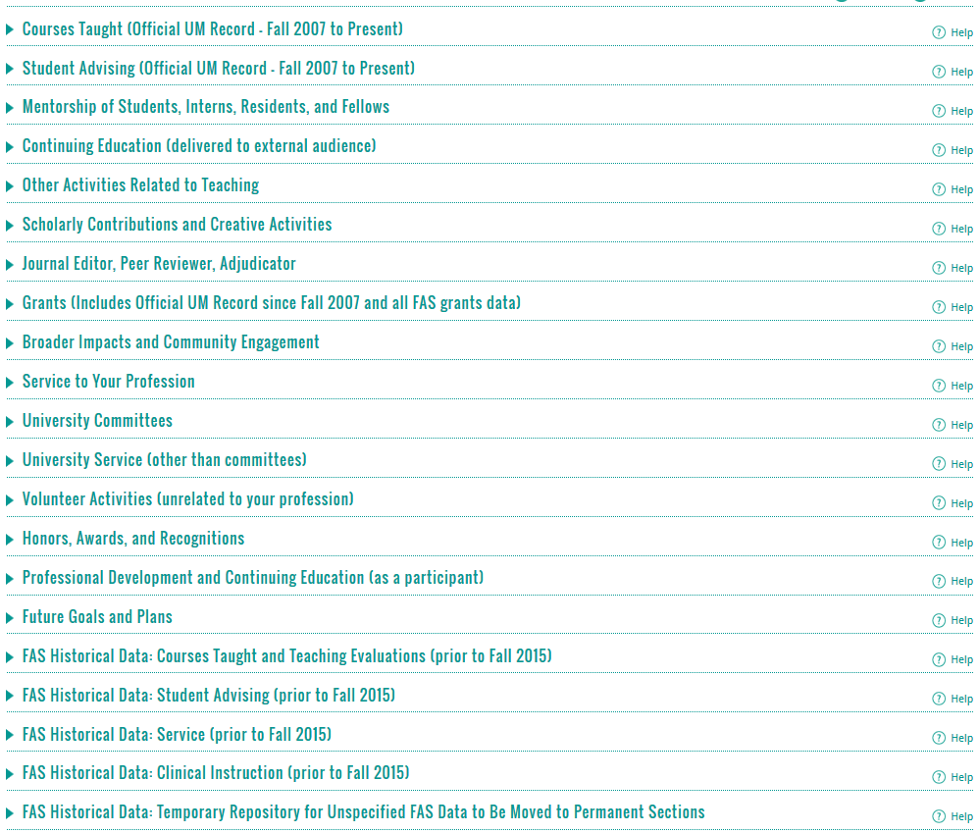
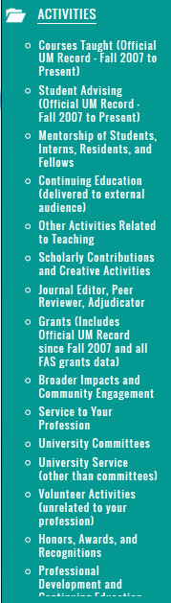

Important note: There are five sections containing FAS Historical information. Two of these sections will be removed after June 2017. You should review and move or delete information from the “FAS Historical Data: Service (prior to Fall 2015)” and “FAS Historical Data: Temporary Repository for Unspecified FAS Data…” sections prior to June 30, 2017.
Courses Taught: This section represents the official records of courses taught from the UM Official Student System. The information in this section is view-only and cannot be edited. Change the date range to view the semesters or years you want to see. FAS Users: To review your historical courses taught data, please go to the "FAS Historical Data: Courses Taught" section at the bottom of the Activity Form. See more information about this section below.
Student Advising: This section represents the official records of advising from the UM Official Student System. The information in this section is view-only and cannot be edited. Change the date range to view the semesters or years you want to see. FAS Users: To review your historical advising data, please go to the "FAS Historical Data: Student Advising" section at the bottom of the Activity Form. See more information about this section below.
Mentorship of Students, Interns, Residents, and Fellows: In this section, you can report any supervision and/or mentorship of undergraduates, graduate students, post-docs and others, including serving on graduate committees. (Mentorship of faculty should be reported in “Other Activities Related to Teaching.”) You can provide information about semester, student, project, and achievements. The Activity Classifications area allows you to further define roles and activities performed. This section also allows you to add attachments if needed.
FAS Users: If you reported information in the FAS “Student Supervision/Committee” section, those records were transferred to this section, as were records about advising Post Docs, Fellows, Residents, and Interns. You may edit, delete, or move this information.
Continuing Education: For this section, you can enter non-credit continuing education teaching activities that were delivered to external audiences. Most Extension teaching activities will be reported here. If a presentation was more scholarly in nature, consider adding it to "Scholarly Contributions and Creative Activities" under "Presentation." FAS Users: Information you reported in the FAS “Extension (Outreach)” section was transferred here. You may edit, delete, or move this information.
Other Activities Related to Teaching: This section allows you to report your other teaching activities, such as curriculum development, and mentoring of other faculty in developing teaching methodologies, classroom technique, or curriculum development. FAS Users: If you reported information in the FAS “Other Teaching
Activities” section, those records were transferred to this section, as were records about advising of Faculty. You may edit, delete, or move this information.
Scholarly Contributions and Creative Activities: Report your scholarly contributions, including articles, books, creative work, presentations, patents, and more. If you publish in Web of Science Core Collection journals, these records were loaded for you back to 2004. Click here to view the myVITA Scholarly Contributions getting started guide and learn about best practices for reviewing any preloaded information you may have.
Note: Conferences attended should be reported in the "Professional Development" section. FAS Users:
Information you reported in the FAS “Scholarly Contributions” section was transferred here. You may edit, delete, or move this information. Click here to view Where’s my FAS data?, which provides details on how FAS Scholarly Contributions were transferred to myVITA.

Journal Editor, Peer Reviewer, Adjudicator: Use this section to report activities where your scholarly expertise is used in the review of others. Examples would include: journal editor, editorial board member, manuscript reviewer, grant reviewer, external P&T reviewer, and adjudicator. Use the Scholarly Contributions and Creative Productions section to report your publications, including books you have edited, and book reviews you have authored.
Grants: You may manually enter and update information about internal grants, gifts, and other funding not tracked by the UM Official Grants System. External grants in the UM Official Grants System have been transferred and are displayed as read-only records. Corrections or modifications of external grants can be managed by your Office of Sponsored Programs/Office of Research. Guidance on how to contact your grants office is included in the Help area of the Grants section of myVITA. Click here to view the myVITA Grants getting started guide. FAS Users: Information you reported in the FAS “Grants” section was transferred here. You may edit, delete, or move this information.
Broader Impacts and Community Engagement: This section captures information about the service you provide to a community that is related to your professional expertise. The more general service or volunteer events you contribute to the community should be listed under the “Volunteer Activities” section. FAS Users: Information you reported in the FAS “Service” section was transferred here if you marked the service as “Community.” You may edit, delete, or move this information.
Service to Your Profession: In this section, list services provided to your profession outside of the university such as serving on boards, chairing committees, etc. Service using your professional expertise provided to the community is listed under the "Broader Impacts and Community Engagement" section.
University Committees: Using the organizational structure, locate the department of the committee. Select the committee(s) on which you serve and indicate your role. If your committee is not listed, select the department level from the organizational structure and manually type the committee name. FAS Users: Information you reported in the FAS “Service” section was transferred here if you marked the service as “Committee Service.” You may edit, delete, or move this information.
University Service (other than committees): In this section, you may report service to the university other than committee service. Examples may include a campus- or system-level search committee, a special task force appointment, program management, event coordination, adjudication, and drafting white papers or other documentation. Your department, college, or school may provide additional guidance.
Volunteer Activities (unrelated to your profession): This section is optional section, but allows you to demonstrate your volunteer activities and service to your community but is unrelated to your profession. Service using your professional expertise should be listed in the "Service to Your Profession" or "Broader Impacts and Community Engagement" sections.
Honors, Awards, and Recognitions: In this section, you can report your honors, awards, and recognitions earned for teaching, community development, research, economic development, etc. This section allows you to report any date range on honors received. Use the Grants section for reporting grants and contracts awarded.
Professional Development and Continuing Education (as a participant): This section captures information about your professional development efforts and includes conferences, symposia, and special training

sessions you attended. You also may report continuing professional education, including those taken for CE credit toward a certification or re-certification.
Future Goals and Plans: This optional section allows you to share and/or store information about your short- or long-range goals.
FAS (Faculty Accomplishments System) information
Five sections were designed to bring other FAS information into myVITA so you can review it, edit it, or delete it. This is FAS information that was not able to be transferred into one of the sections listed above.
Two of these FAS Historical sections, “Service” and the “Temporary Repository”, are for short-term use only. Information in these two sections will be available until June 30, 2017. After June 2017, these sections and the information contained therein will be removed, and administratively deleted from myVITA. Thus, any records in these sections that you wish to keep must be transferred to another section of myVITA.
Note: If you want to keep records from the FAS Historical “Service” or “Temporary Repository” sections, you must move the records (copy/paste) to a permanent section of myVITA by June 30, 2017.
FAS Historical Data: Courses Taught and Teaching Evaluations: FAS course records are informational only, and will not be used for future reporting. For future reporting, information will be maintained in the "Courses Taught (Official UM record - from Fall 2007 to present)" section. In this FAS Courses Taught section, you may choose to edit the information or delete the record, as you may find it useful in the short term for annual reviews for planning.
FAS Historical Data: Student Advising (prior to Fall 2015): This information was transferred directly from FAS and represents data you or your designee added to FAS. Thus, it may or may not match the information in the "Student Advising (UM Official Record - Fall 2007 to present)" section. However, you may choose to add information, edit the existing information, or delete the record if it already exists in the Official Record. Check with your department for options about updating the Official Record. If updating past records isn’t feasible, you can record the correct semester counts of advisees in this FAS Student Advising section for past semesters, and
continue to work with your department on ensuring future semesters’ information is correct in the UM Official Student System.
FAS Historical Data: Service: While most FAS records could be transferred to a corresponding section in myVITA, some Service records were so varied and/or unique that it was not possible to map the data directly to the new myVITA service sections. The “Help” in this section provides guidance on options for moving or deleting information in this section as you choose. This section will remain available for your reference until June 30, 2017, at which time it will be removed from myVITA.
FAS Historical Data: Clinical Instruction: This information was transferred directly from FAS. Refer to this FAS Clinical Instruction section to compare to information in "Courses Taught (UM Official Record - from Fall 2007 to present).”
FAS Historical Data: Temporary Repository for Unspecified FAS Data to be Moved to Permanent Sections: While most FAS records could be transferred to a corresponding section in myVITA, some information was so varied and/or unique that it was not possible to map the data directly to a new myVITA

section. This section will remain available for your reference until June 30, 2017, at which time it will be removed from myVITA. Information was transferred to this section if you reported in the FAS "Optional Activities" section, or in FAS "Other Activities Related to Teaching" with these Activity Types: Academic service learning, Activities focused on teaching improvements, Distance Ed involvement, Electronic learning innovations and
projects, Evidence of teaching effectiveness, and Other.

Please work with your myVITA campus administrator if you have questions. You can find contact information for the myVITA campus administrators at the myVITA informational website.

