myVITA: How to Choose a Delegate
Quick Reference Guide


How to Choose a Delegate Using Access Settings
The myVITA Access Settings feature allows faculty to choose another person as a delegate. Delegates whom you select will be able to enter information for you. They will have access to your Profile and Activity forms, as well as your personal CVs, Biosketches, and individual reports. Delegates do not have access to evaluations, present or past. Upon signing in using their own credentials, delegates see a list of myVITA accounts to which they have access. There is no need to share your credentials with others!

In order to select a delegate, the person you wish to choose must have an account in myVITA. If your chosen delegate is not in myVITA, please contact your myVITA Coordinator. You can find contact information for the myVITA campus administrators at the myVITA informational website.

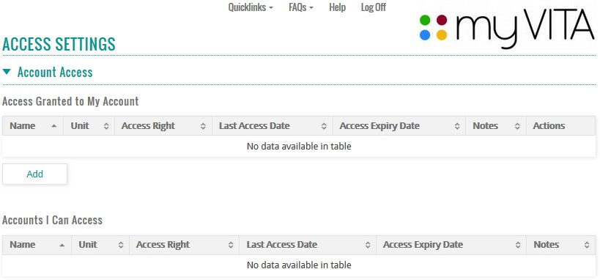
- To begin selecting a delegate, click Access Settings in the left-hand navigation. On the next screen, you will see the following:

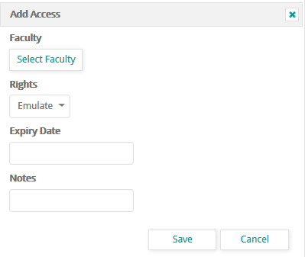
- Click the Add button.

- In the pop-up window that appears, click the Select Faculty button.

Note: “Faculty” on this button is a bit of misnomer as you may choose from faculty and support/staff accounts.

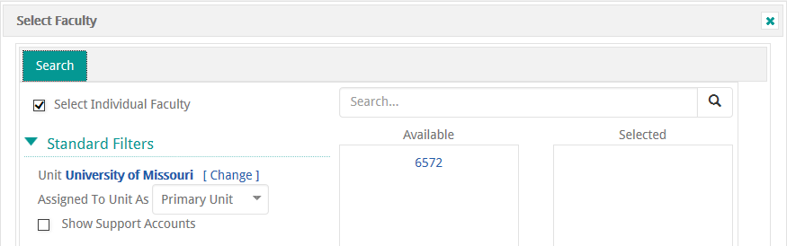

- The Select Faculty window will display. This is where you can search for and select your delegate. If you want to select someone with a support account (an administrative assistant for example), be sure to select the Show Support Accounts check box.
Note: You do not need to change the Unit or the Assigned to Unit As filters.

- With the Select Individual Faculty check box selected, type the person’s last name in the Search field at the top right and click the magnifying glass or press Enter on your keyboard. A list of people will appear in the Available column. Currently, if you include the person’s first name, no results will return.
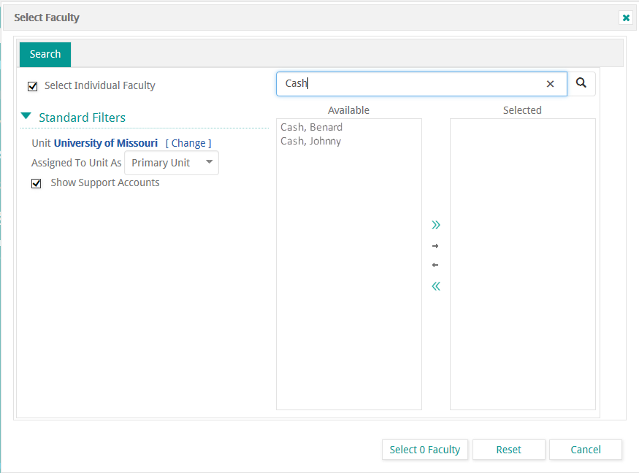

- Click the name of the person you wish to select. If only one name appears, you must still click the name to select the person.
- Click the Select Single Arrow (see image with the arrow circled in red at right) to move the person you selected from the Available column into the Selected column. If you select the wrong person, you can use the Remove Single Arrow to move the person back to the Available column.

- Once you have made your selection, the Select 0 Faculty box at the bottom of the pop-up window will change to Select 1 Faculty.
- You will return to the previous pop-up, where you can choose the delegate’s rights and expiration date.
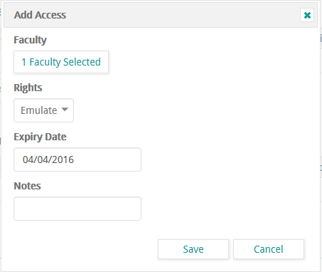
  - Currently, the only Rights you can grant someone else is Emulate. This is the default selection. In the future, other options may become available.
  - Expiry Date is required. Click in the box and a Calendar Picker tool will pop up. Use this calendar to select the date you would like these rights to expire. You can set this to a few days, several weeks or months, or years out into the future.
  - The Notes field is optional. You may choose to add more about who this person is, or how they help you (“department admin assistant” or “librarian” are examples.)

- Click the Save button.
- You will see a pop-up that says Access Added. Click the Okay button.
- In a moment, you will see the person added to your list of those with Access Granted to My Account. Note: The delegate does not receive any notification from the system. You need to be sure you communicate the responsibilities to your delegate.

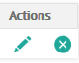
At any time, you may edit or delete a delegate. Use the Edit icon to change the expiration date or other information about the person. Or use Delete to remove the person from having account access. Some departments have “pre-assigned” delegates to your account to assist with reporting or other department needs. These assignments were approved by their department, dean, or campus administration.

Browser recommendations: myVITA features work best in Mozilla Firefox, Google Chrome, and Safari browsers. Internet Explorer is not recommended because of issues with functionality and display. Please set your browser to accept pop-ups from the myVITA site to ensure an optimal experience.
Please work with your myVITA campus administrator if you have questions. You can find contact information for the myVITA campus administrators at the myVITA informational website.

