Activities Form: Scholarly Contributions & Creative Activities
Getting Started Guide


Scholarly Contributions & Creative Activities

Reviewing Your Information

Check for Duplicates.
The Scholarly Contributions & Creative Activities section of the Activities Form has been pre-populated with historical records from the Faculty Accomplishment System (FAS) and other home-grown systems and with a one-time bulk load of Web of Science Core Collection records from 2004 – October 2015. The Source of Data column will let you know if the record came from FAS or the Web of Science load (WOS).
Depending on your use of FAS and where your research is published, you may have duplicate records. The easiest way to find duplicates is to Show All entries and sort by Title (click on the Title column header). If you have a duplicate, delete the FAS record and retain the WOS record.
Why retain the WOS record? You can include current times cited information on your CV if the record has come from Web of Science.

Check for Accuracy: FAS and Other Legacy Systems.
Because the legacy systems were structured very differently from myVITA, you may find that some of your information does not come through as expected. You may also find that your information was not updated or entirely accurate in the legacy system itself. If you feel it is appropriate to delete the FAS record, please do so.
  - Is the Status of your FAS information correct? For example, does a published Book Chapter still have a Status of Submitted? Edit the record and Manage Status.
  - Is the Type of your FAS information correct? Do you have anything labeled Unspecified Data: FAS? You can edit the record to change the Type.
Tip: Before changing the Type, first answer the required questions on peer review and funding type, then save the record. Then change the Type and edit other fields as appropriate.
  - Are you listed as a Co-author? In FAS, many records did not specifically list the UM System faculty member as a co-author. If you are not listed, add yourself and adjust the co-author list as needed.

Check for Accuracy: Web of Science Core Collection One-Time Load.

Since no bulk load is 100% correct, check to make sure that the WOS records are indeed yours, especially if you have a common name. Delete the WOS records that are incorrectly attributed to you.

Activities Form: Scholarly Contributions & Creative Activities Getting Started Guide

Entering New Information
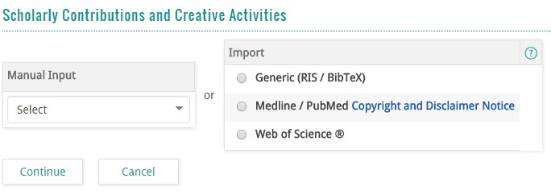
In myVITA, you can add new information via Manual Input or via Import. The Import feature allows you to download citations directly from Medline / PubMed and the Web of Science Core Collection. You can also import information in RIS and BibTeX. See below for tips:

  - We’ve pre-loaded thousands of journal titles. If you are manually entering a journal title, simply start typing your journal title and pick from the list.
  - You don’t need to fill in all the fields. If your item doesn’t have a DOI, or you don’t know the ISSN, leave the field blank.
  - Use the “Issue” field for season or month designations (e.g., Summer; October). The “Date” field is useful for ePub ahead of print articles.
  - Author Searching: In Web of Science, you must use the following format: LastName, FirstName.
In PubMed, you can do any of the following: FirstName LastName | LastName FirstName | LastName F | LastName FM. Note: do not use commas.

FAS Users:
For information about how your FAS Scholarly Contributions data was transferred to the new myVITA categories, go to the myVITA guide Where’s my FAS data?

More Information:
For FAQs on this topic, go to the myVITA FAQs page and click the Scholarly Contributions & Creative Activities tab.
Browser recommendations: myVITA features work best in Mozilla Firefox, Google Chrome, and Safari browsers. Internet Explorer is not recommended because of issues with functionality and display. Please set your browser to accept pop-ups from the myVITA site to ensure an optimal experience.
Please work with your myVITA campus administrator if you have questions. You can find contact information for the myVITA campus administrators at the myVITA informational website.

