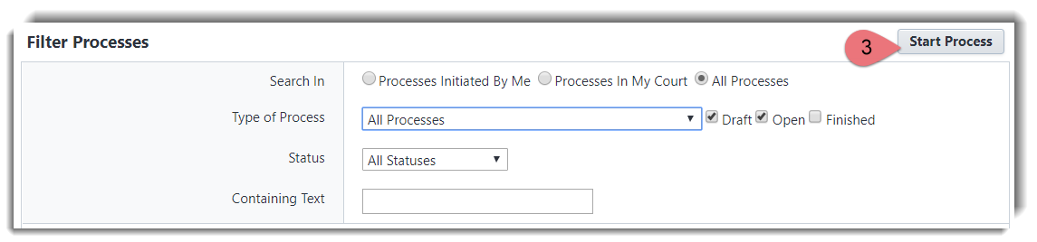**Start Process**

1. Click on the **Projects** tab and select the project.
2. In the left-hand navigation, click on **Processes**.
3. Click the **Start Process** button
4. A new window will open. Click on the name of the process. If the process is not listed, you don’t have permission to initiate the process. Contact your eB Admin if you think you should.
5. Complete ALL required fields and click **Submit**.

*OR*

1. Home Page under the Quick Start menu, select the process.
2. A new window will open, select the project.

**View Process Status**

1. Click on the **Projects** tab and select the project for which you would like to view the status of a process.
2. In the left-hand navigation, click on **Processes**.
3. In the **Search In** field, click **All Processes**.
4. Click on the drop-down menu for **Type of Process** and select **the process you want to view**.
5. Click **Filter**.

**Respond to a Process. (*Workflow in your court*)**  
You will receive an email notification from e-Builder if a workflow is in your court, the **click here** link will prompt you to log in. Enter your credentials and it will take you directly to a pop-up window to review the request.

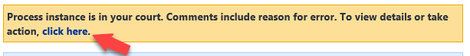

Alternatively, you can log in to e-Builder. The workflow will be listed in Home page under the **Workflow in your Court** section. Click under column “**Name**” for the project you want to review, and it will take you directly to a pop-up window to review the request.

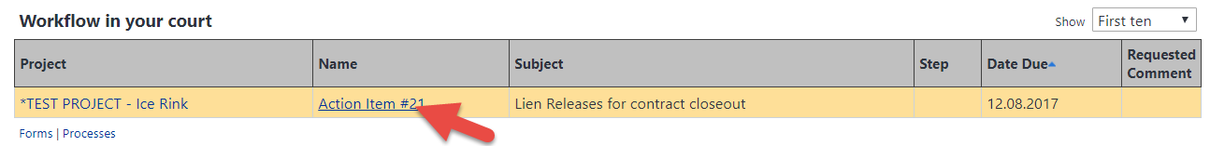

**Navigate Within a Process**

You can navigate within a process step to reveal information about the process itself:

1. *Show History*. You can see routing history and historical information.
2. *Current Actors*. These are the users that can act upon *this* step.
3. *Show Workflow Diagram*. It shows graphically where in the workflow you are.

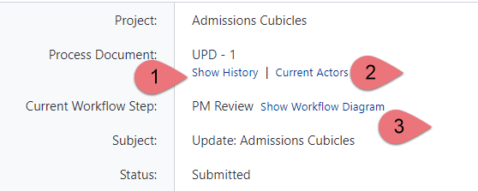

Review all other fields in your step before you take action (see how to Take Action below)

**Make Comments**

You can make comments in a process step by selecting the Comments tab and then click on **Comment**.

**Attach Documents**

If you don’t see a field to upload your document, you can always upload document(s) to a process by selecting the *Attached Documents* tab and then click on **Attach Documents**. Or you can click & drag documents.

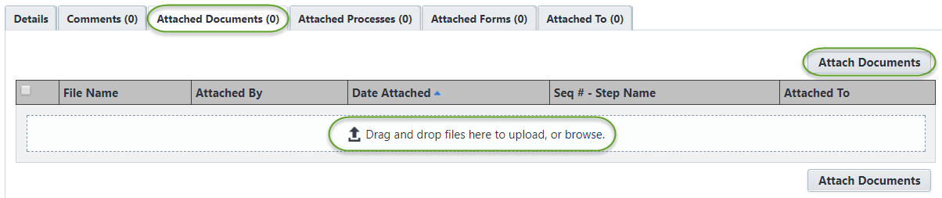 **Take Action**  
Once you review the information and you’re ready to proceed, then you take an action:

1. Scroll to the top (or bottom).
2. Select the action from the drop-down.
3. Click **Take Action**.