ADDENDUM I
DATED: March 26, 2024
For
Request for Qualification to Pre-Qualify
General Contactors for KC656503
School of Medicine Steam Line
For the University of Missouri – UMKC

The following question was received, and clarifications/answer provided below:
- Is it possible to get a sketch or a little more detail about the above referenced project?
Answer:

Project SOW to include the installation of a new steam service line to serve SOM with steam service from the adjacent Health Science Building (HSB).
  - New 300’ L 4’ Wx3’3” H steam chase between the School of Medicine Building and the Health Science Building
  - New 12” steam, 4” condensate piping at HSB with interface to existing steam header and surge tank
  - New 10” steam and 4” condensate piping at SOM with interface to existing 10” steam line in SOM loading bay.
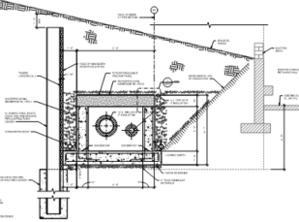

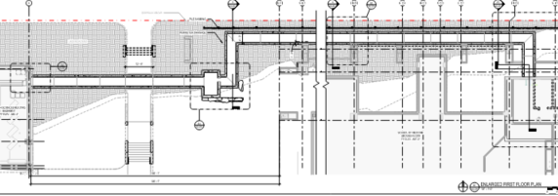

- Confirm the cover page does not count against the page limit.
Answer: The cover page does not count against the page limit

End of Addendum I

